

**SAN JOSE STATE UNIVERSITY**

**Project Report On:**



**Simulation of indeed using Distributed Enterprise Technologies**

Under the guidance of,

Prof. Simon Shim

**CMPE 273 Enterprise Distributed Systems**

**Fall 2021**

**Team 07**

**Anagha Sethuraman (015220517)  
Himakshi Vijayvargiya (015351453)**

**Komal Joshi (014682551)  
Ruchita Dinesh Entoliya (015331966)**

**Sherin Thlakulathil Elias (014635504)  
Shivani Sanjay Degloorkar(015237664)**

**Contributions**

* **Anagha Sethuraman**

1. Landing Page and Navbar UI for Employer. (E2E)
2. Company and Employer Profile Page - Add/Update. (E2E)
3. Job Posting Page
4. Applicant Page - Displaying list of applicants, applicant’s profile, applicant’s resume and view/update application status.(E2E)
5. Mocha Tests for 10 APIs.
6. Worked on Sign Out functionality and kafka changes for other persona.
7. Performance testing for 100, 200, 300, 400, 500 users dealing with 10k reviews.

* **Himakshi Vijayvargiya**

1. MYSQL database setup on AWS RDS.
2. Find Salary and find salary by title Page on the Jobseeker. (E2E)
3. Add salary Review Page under Company Tabs. (E2E)
4. Employer Report Page. (E2E)
5. Admin Analytics Page. (E2E)
6. Access Restriction without login for all the pages in the application.

* **Komal Joshi**

1. Redux setup, including reducers and logout behaviour
2. Kafka set up and documents creation for submissions.
3. Job Seeker profile management including updating profile, resume management(upload/delete/download/replace from S3), job preference handling (E2E)
4. Created Snapshot and about us page (E2E)
5. Enabled kafka testing for 10k reviews data
6. Mongo setup
7. Sign in and Sign Up UI, Admin Sign in Sign up (E2E)
8. MyJobs including Saved and Applied jobs (E2E)
9. Performance testing for 100, 200, 300, 400, 500 users dealing with 10k reviews.
10. Bug fixes.

* **Ruchita Dinesh Entoliya**

1. Database design of the entire application
2. Implemented Signup, login backend functionality with passport JWT authentication implementation for all the personas
3. End-to-end implementation of upload company photos and my photos functionalities.
4. End-to-end implementation of the admin photos, admin reviews, admin company and company statistics pages
5. Implemented end-to-end messaging functionality on both jobseeker and employer pages
6. Created API documentation, design sections of presentation and report for the application
7. Actively involved in coordinating with the team and assisted team with fixing issues

* **Sherin Thlakulathil Elias**

1. Redis setup and caching company snapshot data in redis.
2. Performance testing for 100, 200, 300, 400, 500 users dealing with 10k reviews for redis configuration.
3. Reviews tab for company with sorting based on helpfulness, rating and date, filtering for rating.(E2E)
4. Review this company modal for adding reviews to each company.(E2E)
5. Company reviews tab for showing all company reviews and search by company and location.(E2E)
6. My Reviews page under profile listing company reviews added by logged in user.(E2E)
7. Employer reviews page for viewing reviews and marking featured reviews.(E2E)
8. Post job UI.
9. Final application deployment in AWS

* **Shivani Sanjay Degloorkar**

1. Landing page for Job Seeker (E2E)
2. Navbar UI for Job Seeker
3. Company Homepage UI
4. Jobs tab in company homepage (E2E)
5. Apply to jobs page(E2E)
6. Deployed application on EC2 with load balancers and auto-scaling for performance testing and comparison.
7. Performance testing of applications deployed on AWS with above configuration for 100, 200, 300, 400, 500 users.

**Database Schema**

**MySQL database schema**

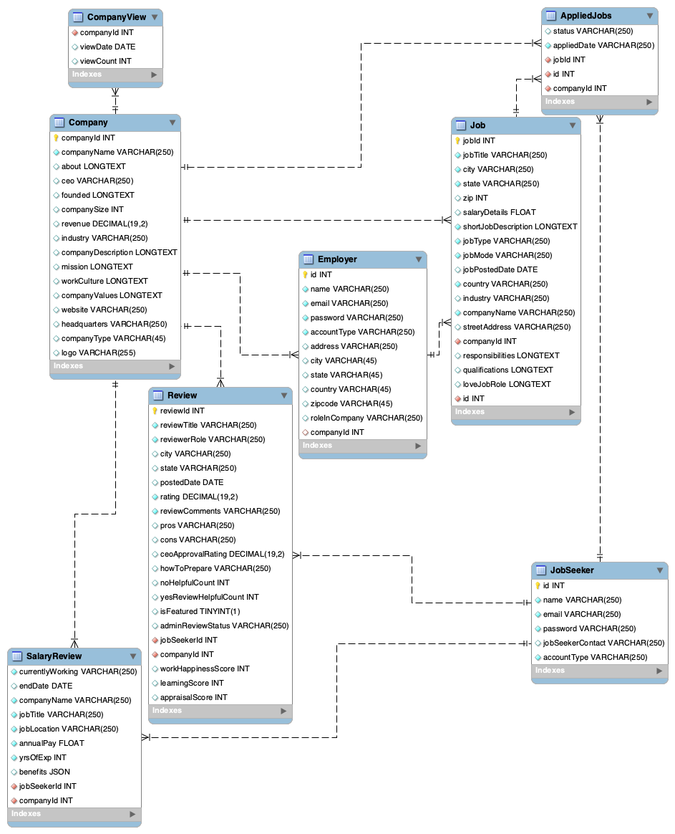

**MongoDB database schema**

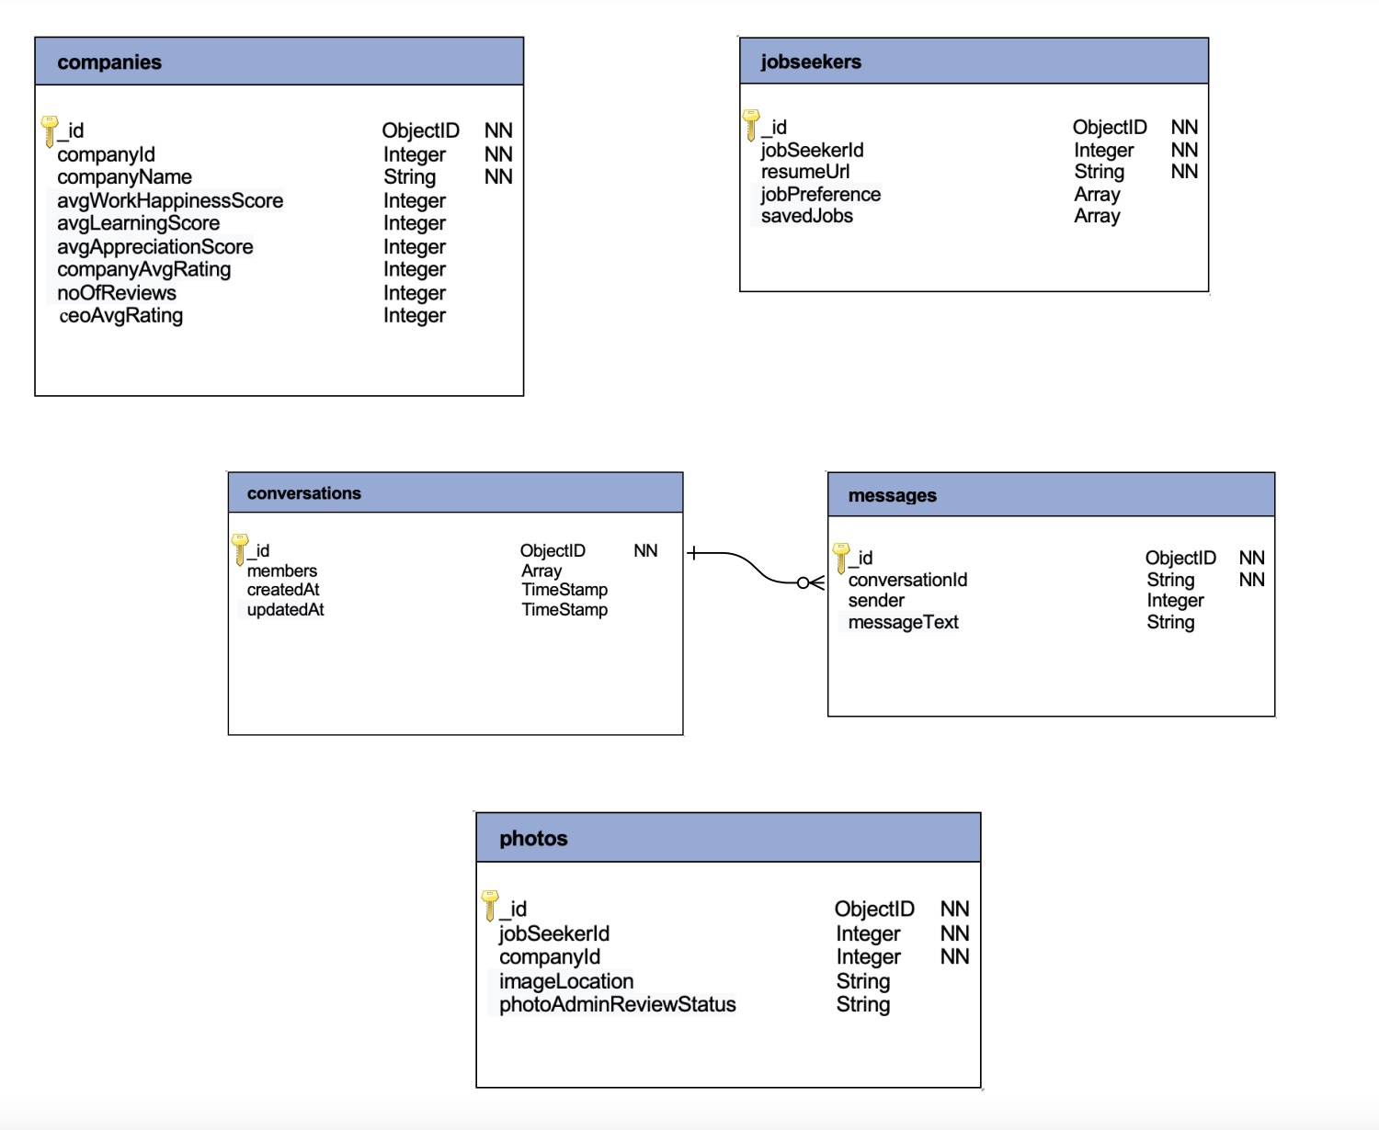

**System Architecture Design Diagram**

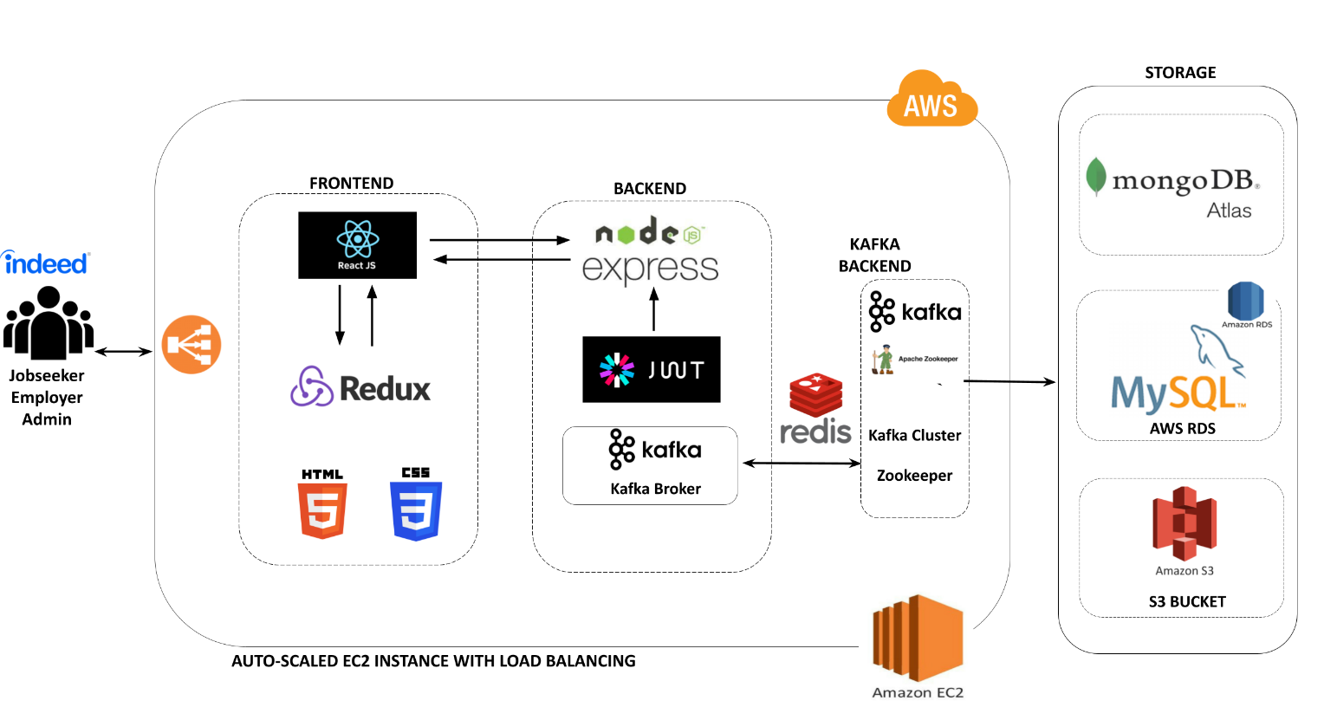

**Notes**

**Object Management policy**

**Backend**

* The primary tables JobSeeker, Company and Employer which hold the sensitive information are stored in MySQL.
* As MySQL is a relational database and enforces integrity constraints, all the other tables like Job, AppliedJobs, CompanyView, SalaryReview, Review which are related and hold references to either JobSeeker/Company tables are stored in MySQL.
* MongoDB fetches the data with higher throughput and is efficient in handling complex data types; the photos, messages and company metric related information is stored in MongoDB. MongoDB supports horizontal scalability and document size of about 16MB.
* Images and resumes are stored in Amazon S3 bucket for faster data retrieval.

**Frontend**

* Redux is used to store user information, company related details and featured reviews. Information stored in redux stores is readily available across all the components of the application. It provided the feature of plug and play so that it is easy to use hooks for fetching the state of the objects.

**Heavyweight Resource Handling**

**Connection Pooling**

* We are using connection pooling as it helps to achieve better system performance. It also makes it easy to handle traffic when the application scales up.

**Redis Caching**

* For faster retrieval of the data from the database we used redis cache. The data that is not frequently changing is stored in the redis cache like the company snapshot information. It aids to optimize application performance.

**Kafka**

* Kafka the distributed messaging system helped to provide fault tolerance and scalability to our project. The application performance improved with a greater number of concurrent requests.

**Database write policies**

**MySQL**

* For data protection, we have stored the sensitive information of JobSeeker, Company and Employer in MySQL
* All the related data like company reviews/salary reviews, company views, jobseeker applied jobs are stored in MySQL as it works better to structure the data better and handle all integrity constraints

**MongoDB**

* As mongoDB is schemaless, scalable and provides an easy support of complex data types we have stored photo, messages, and company metric information in MongoDB.
* Auto sharding helps to increase the application performance

**Screen Captures of the application**

**Common Pages for all persona :**

Default landing page

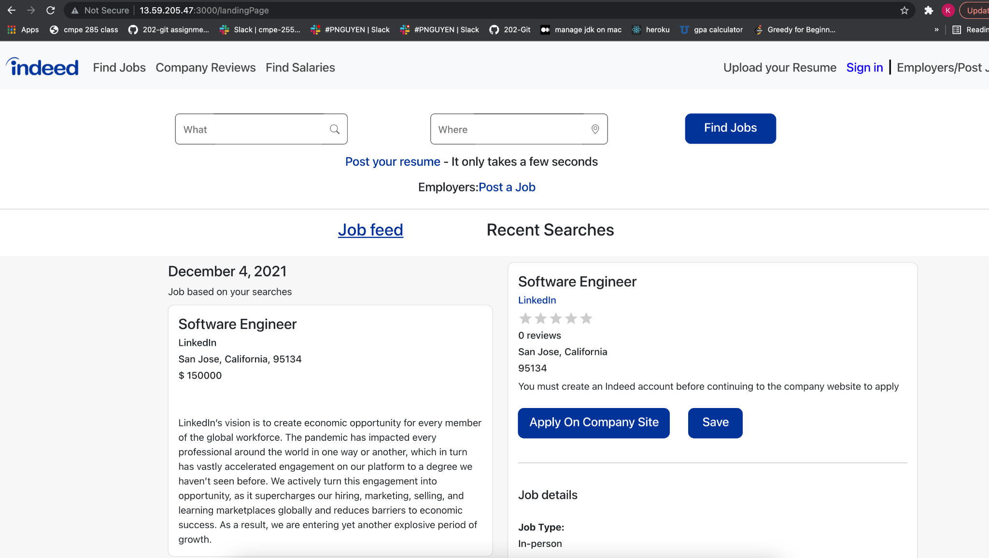

Sign In Page

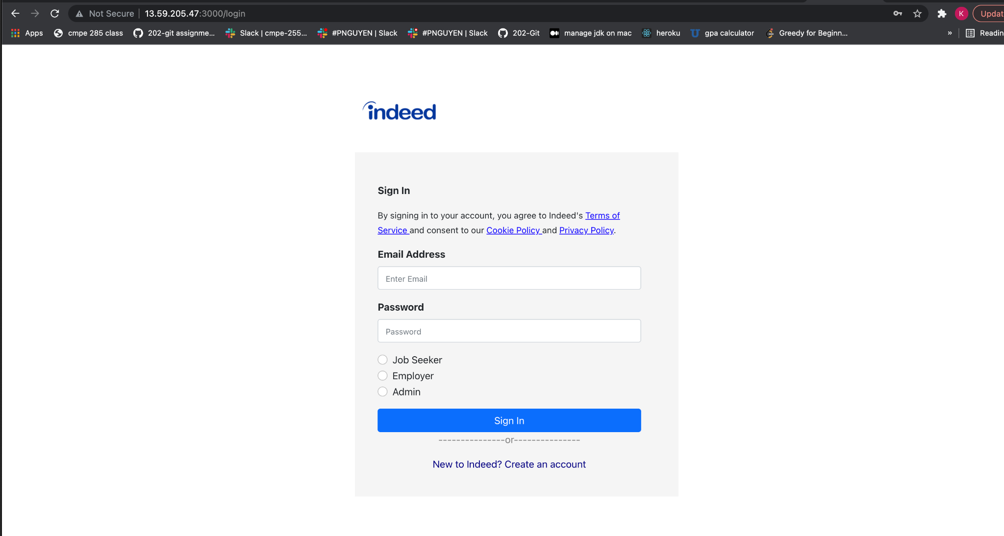

Sign up

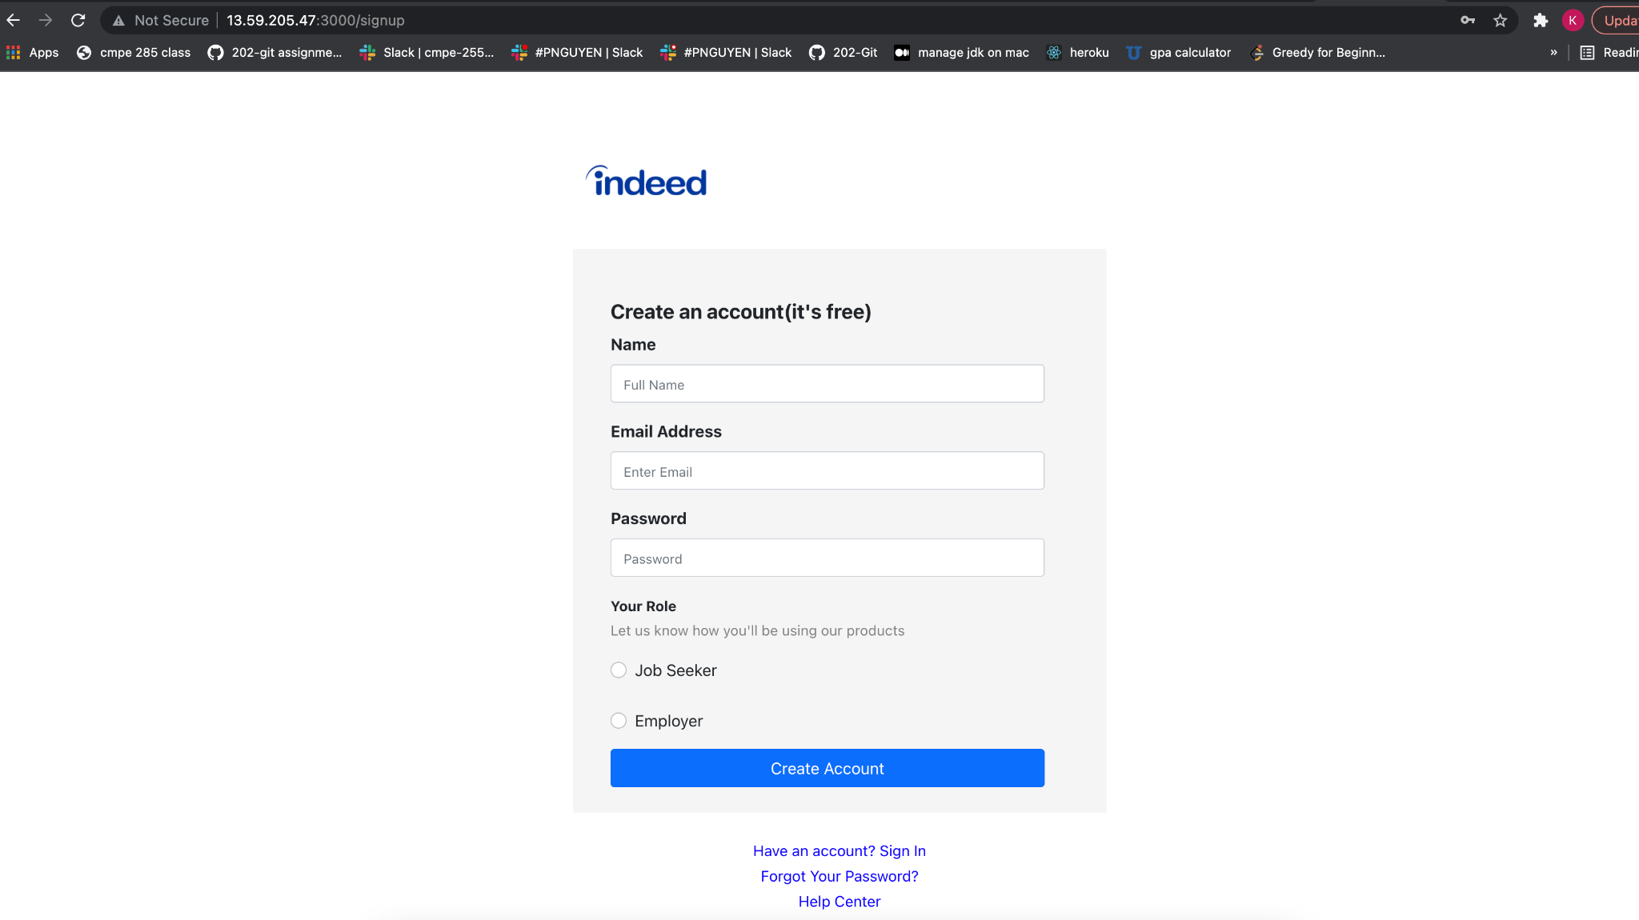

**JobSeeker Pages:**

Job seeker - After Sign In

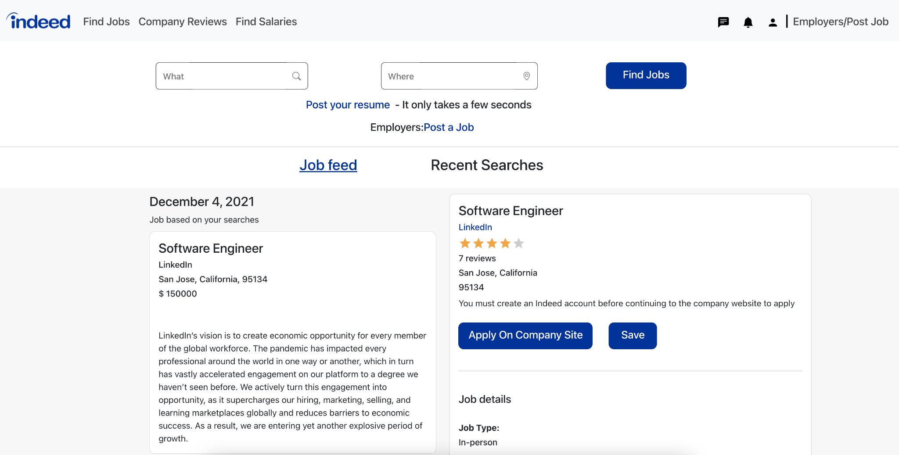

Showcasing pagination in landing page

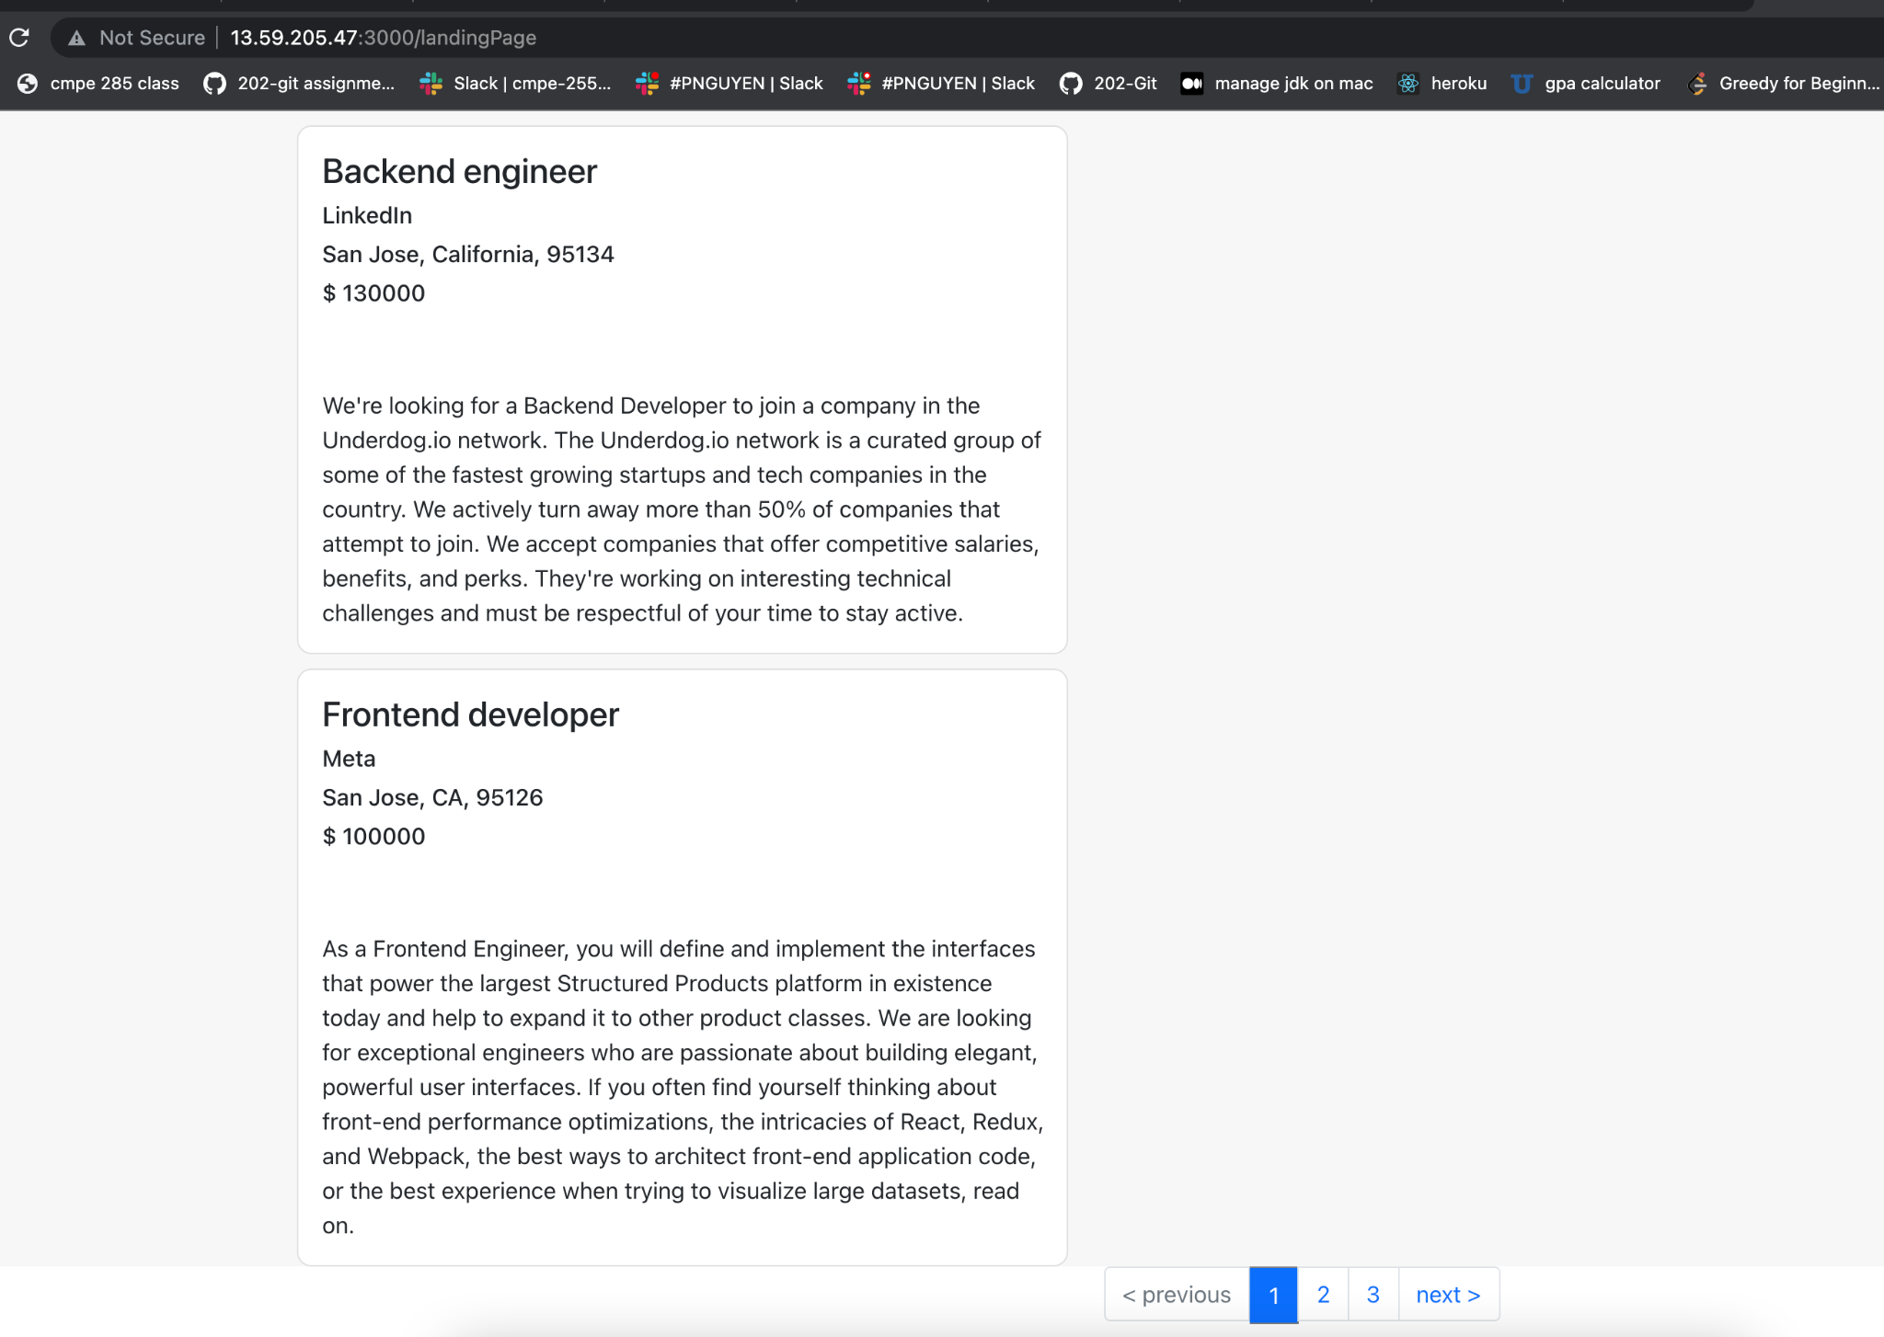

My Profile

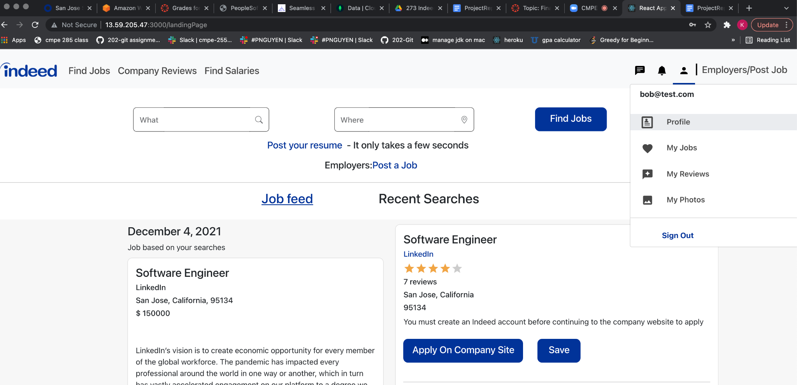

Add/Download/Remove Resume

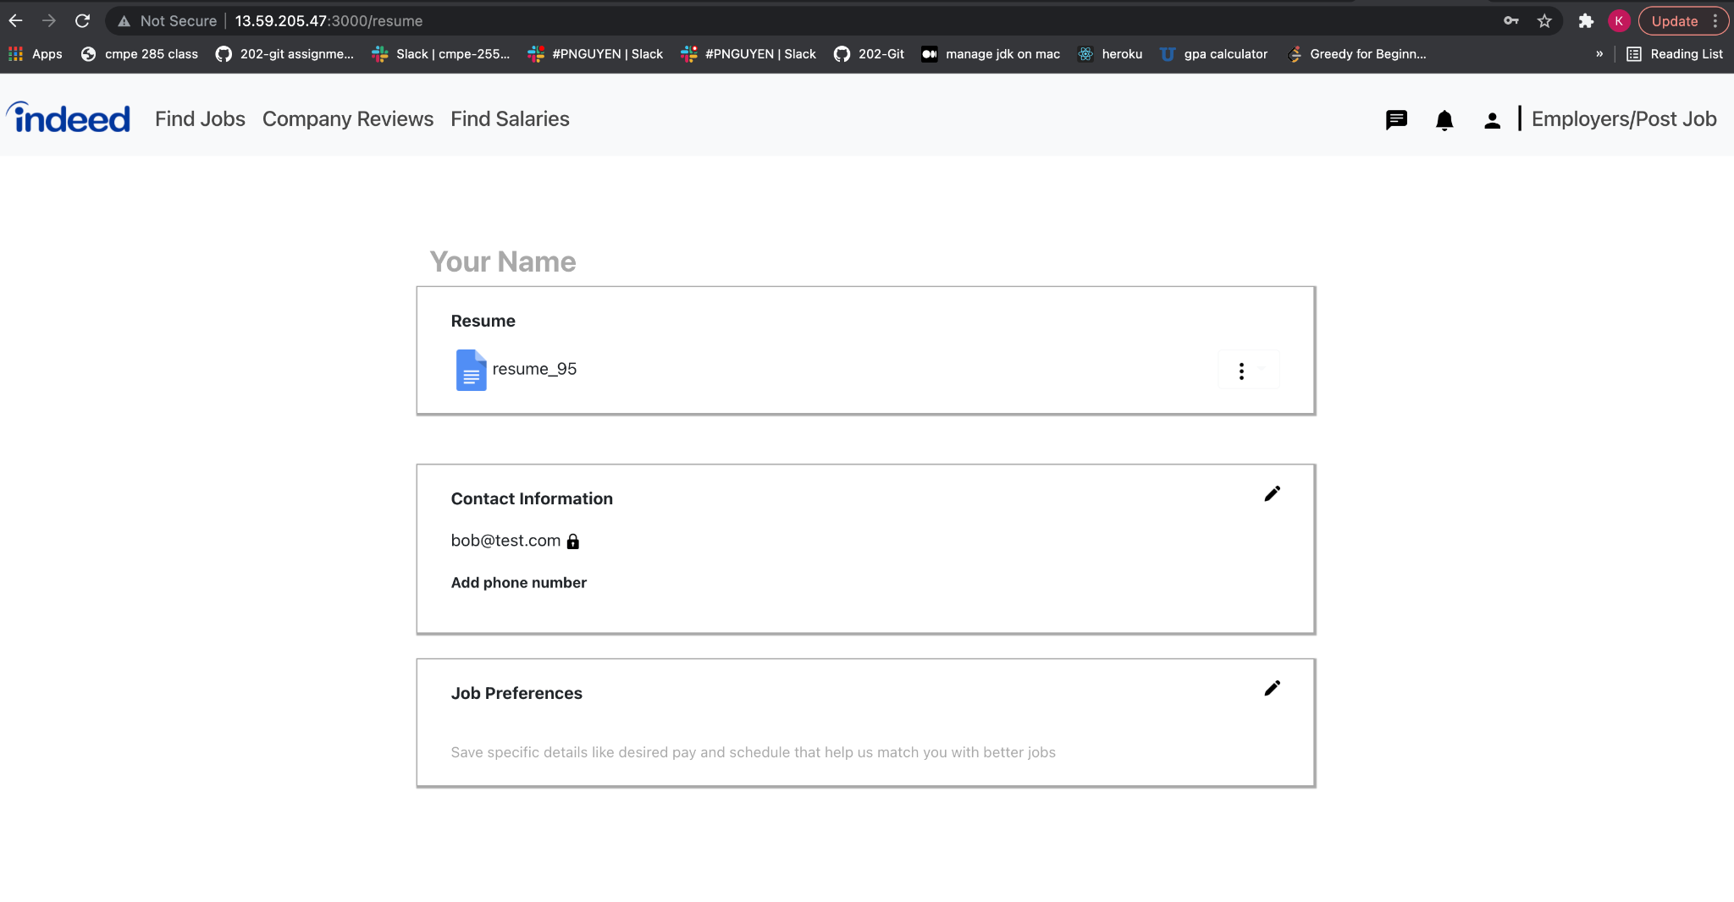

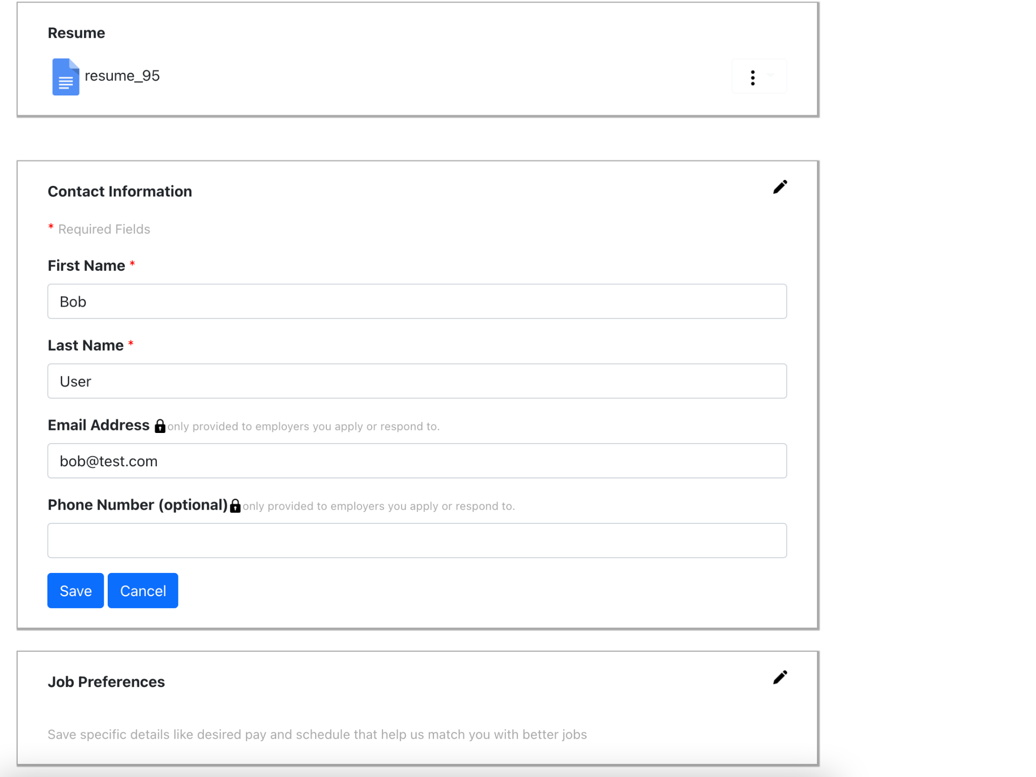

JobSeeker - job Preferences

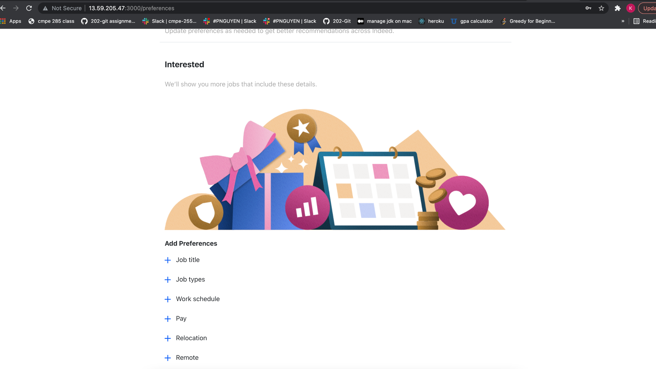

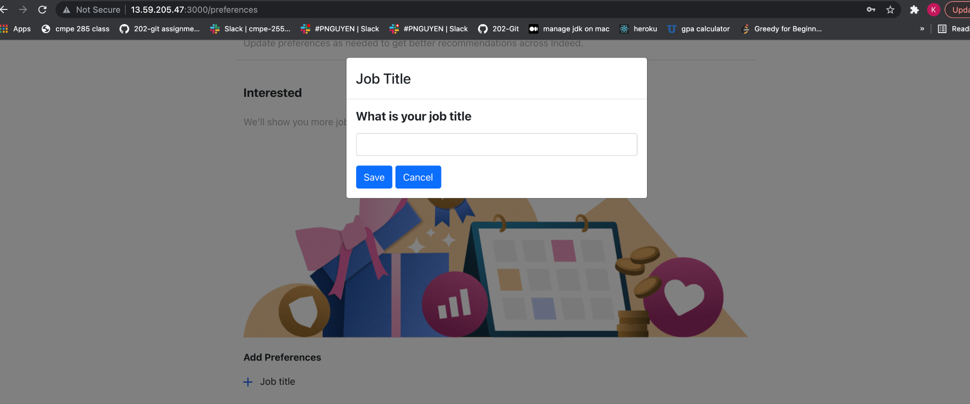

My Job- Saved/Applied

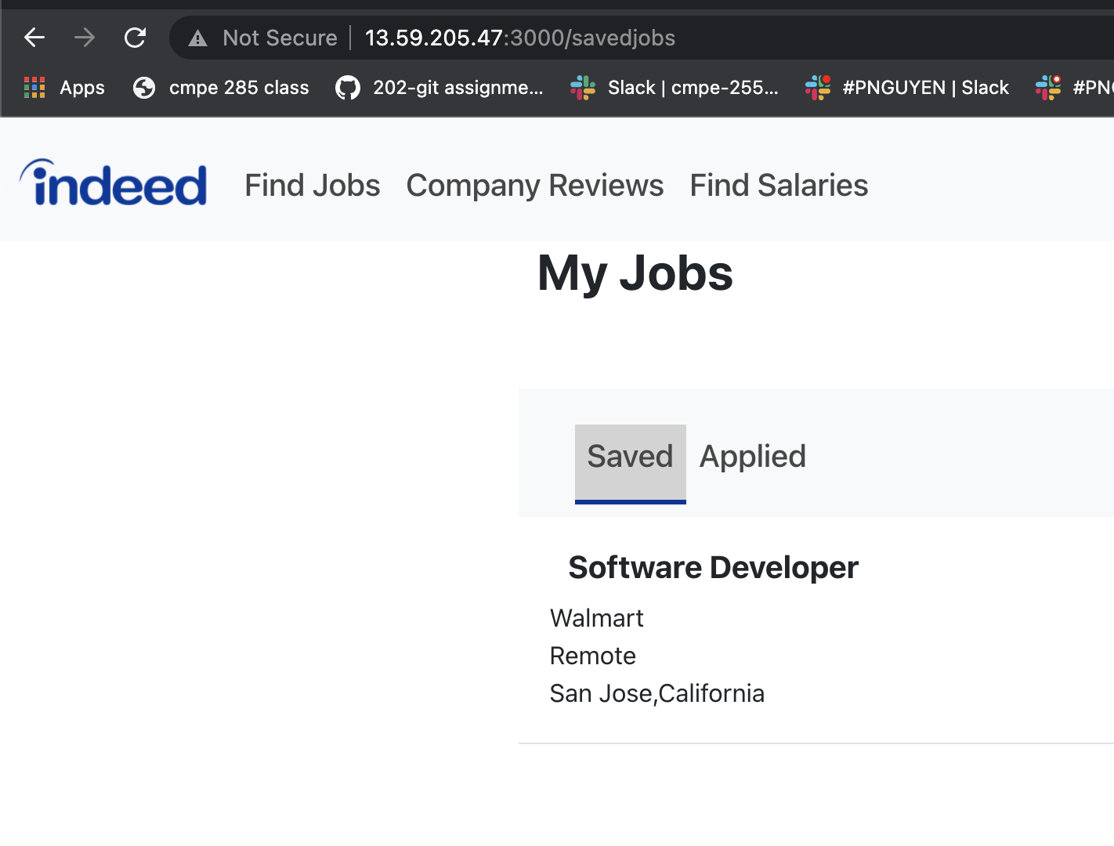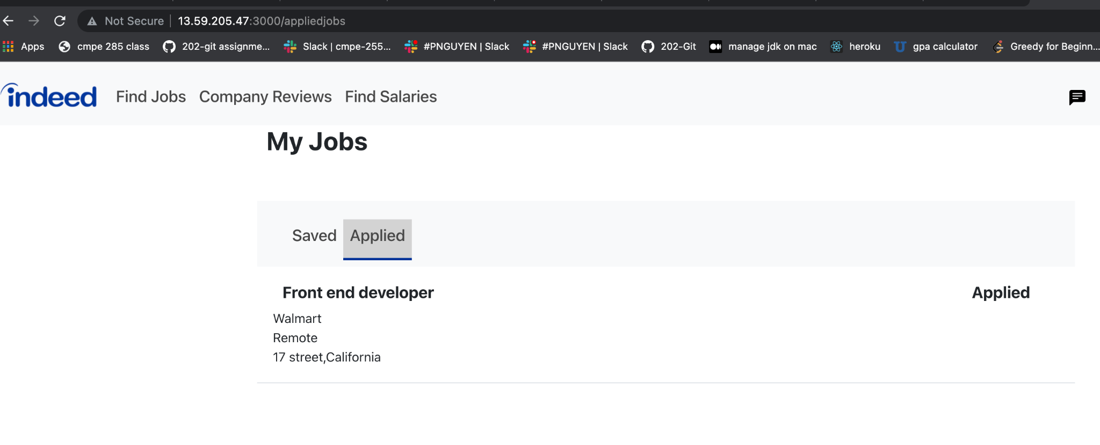

My Reviews

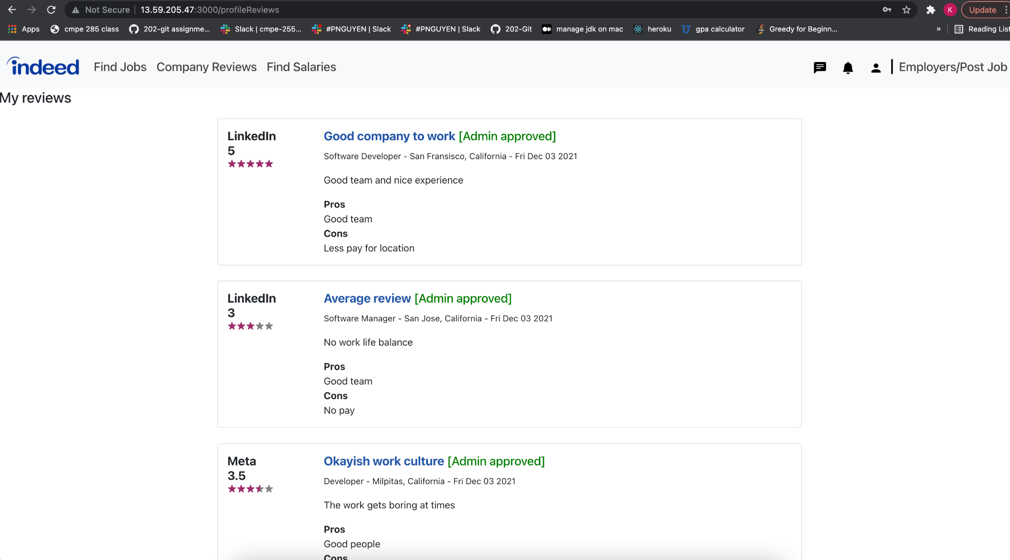

JobSeeker Messenger Page

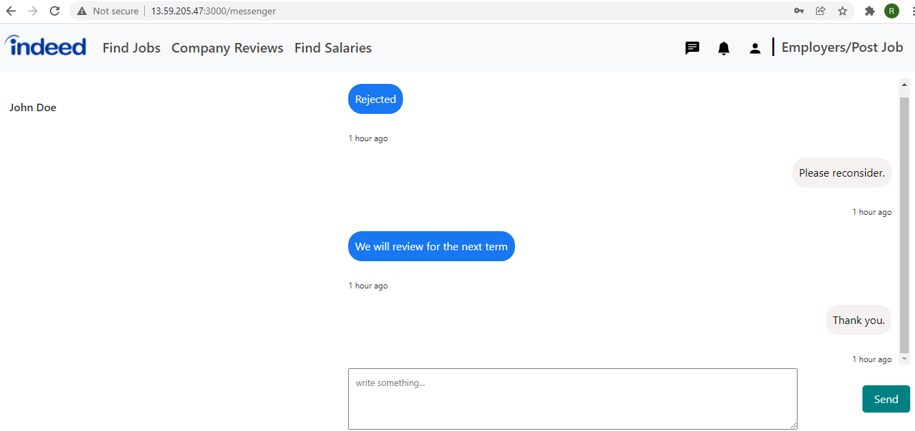

Why join us tab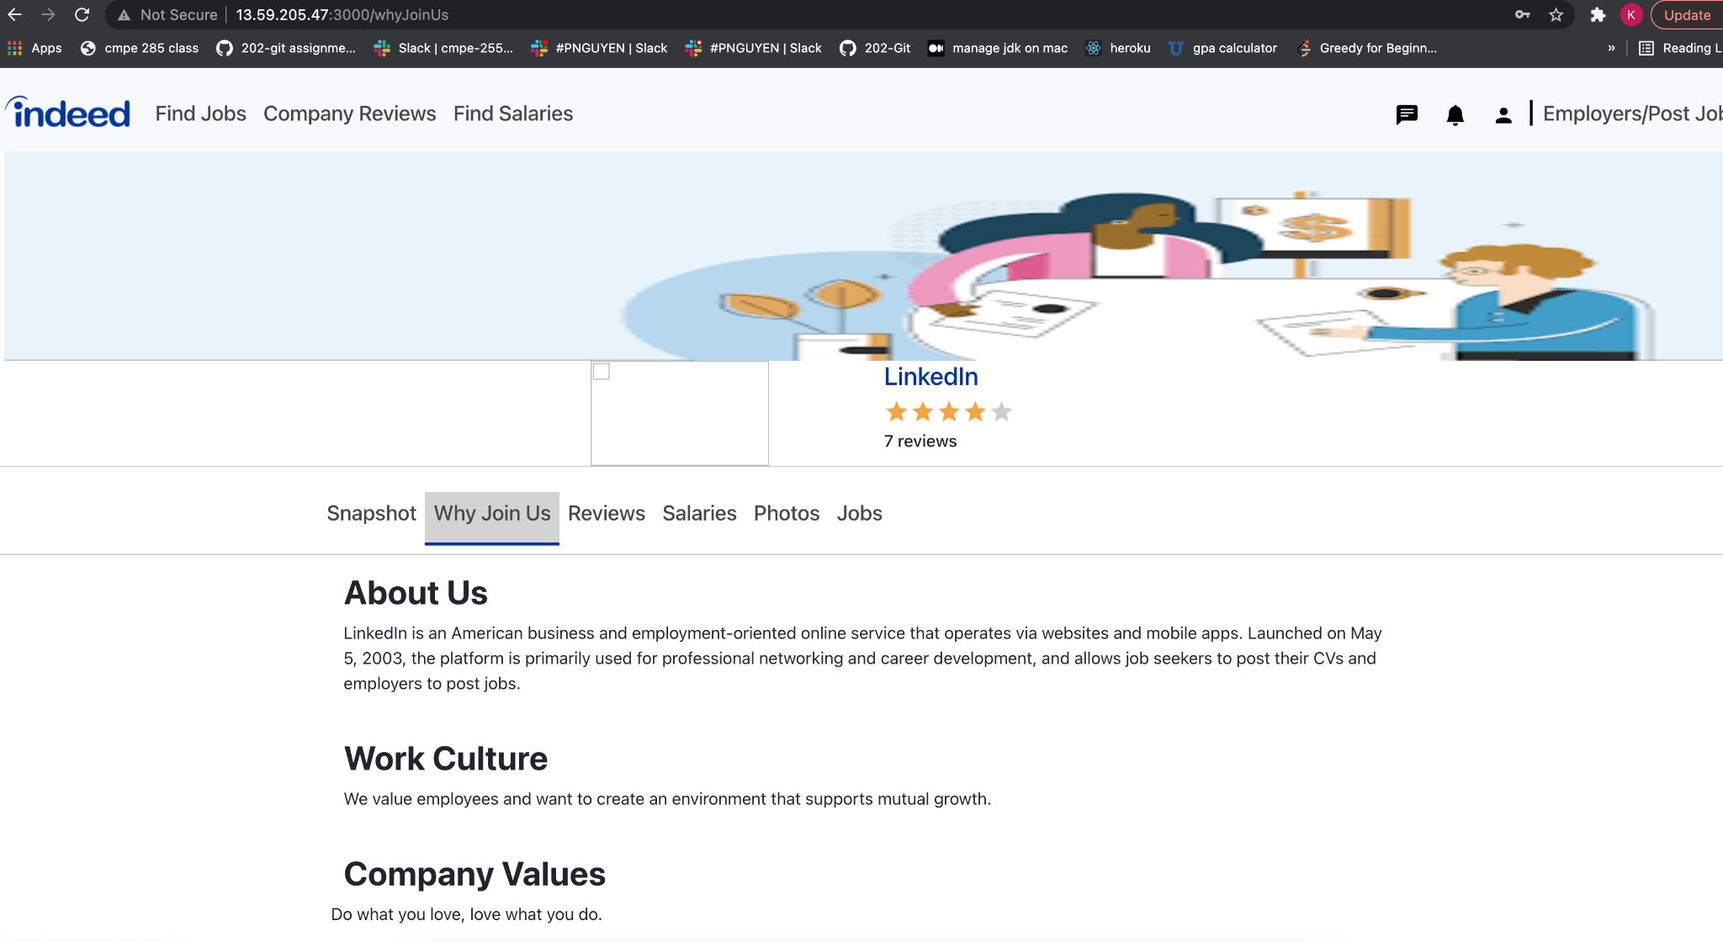

Snapshot tab

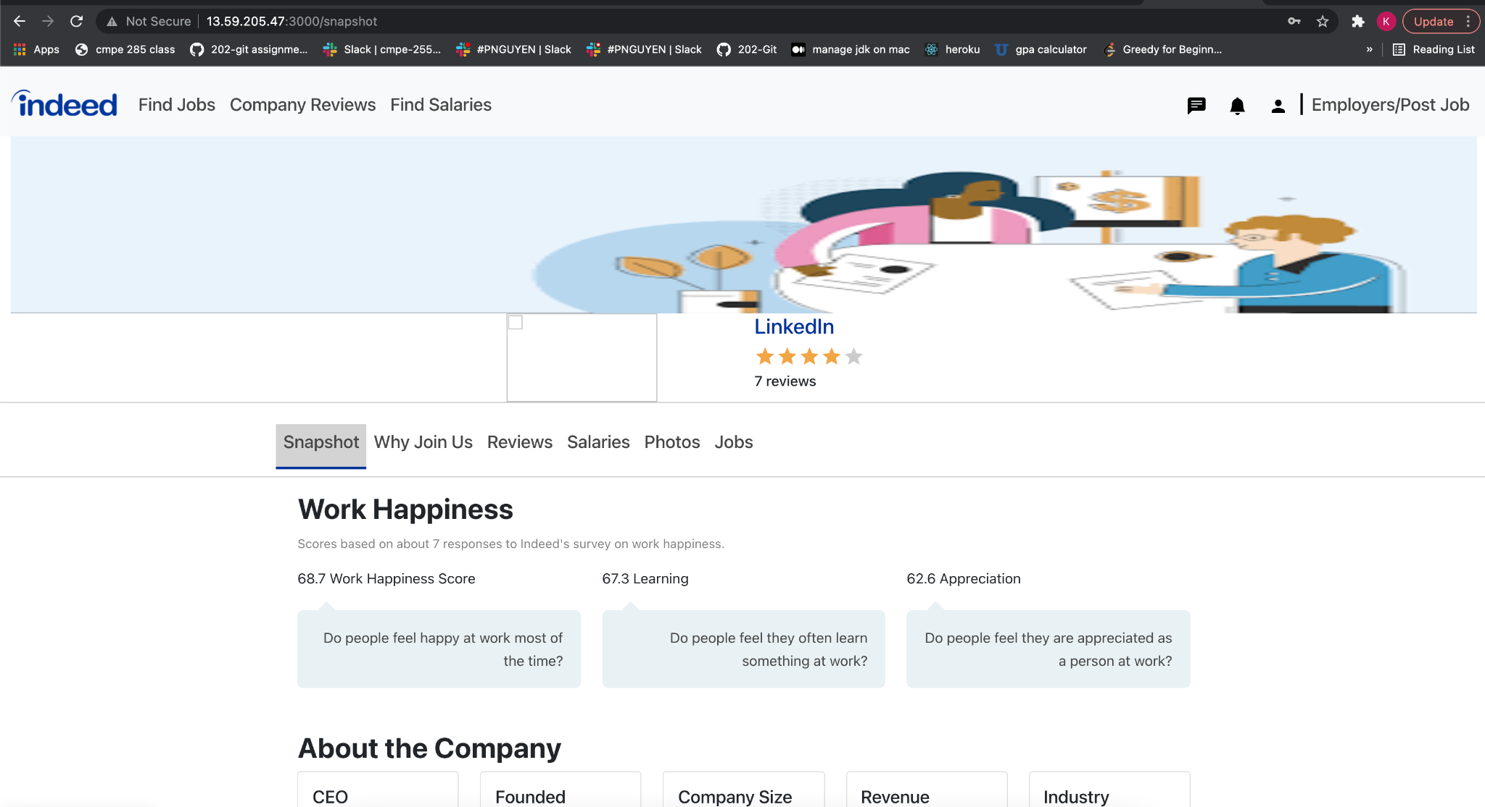

Company Photos tab

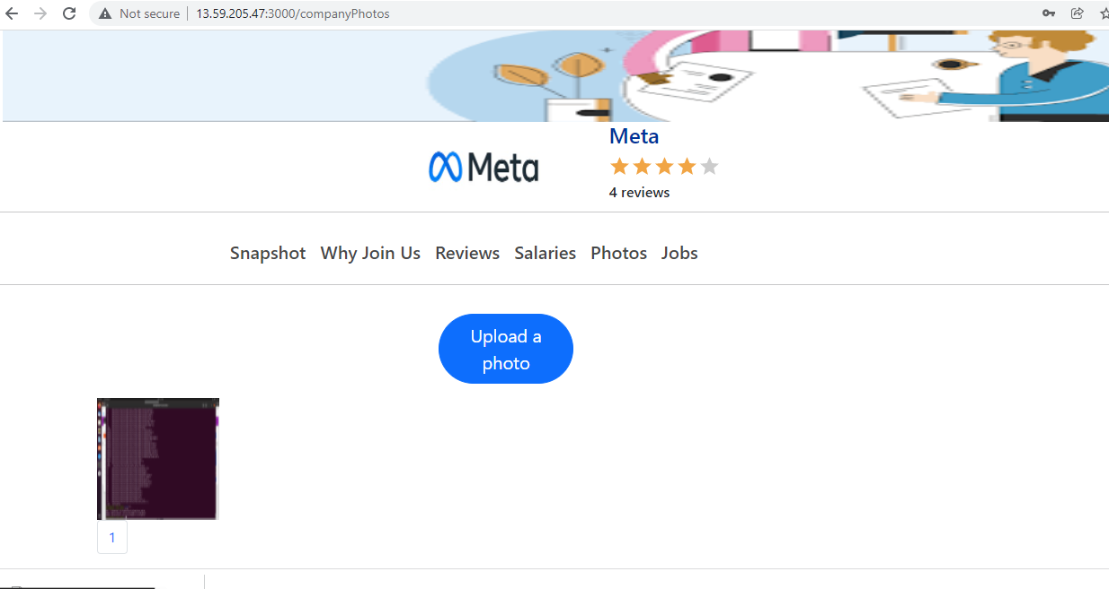

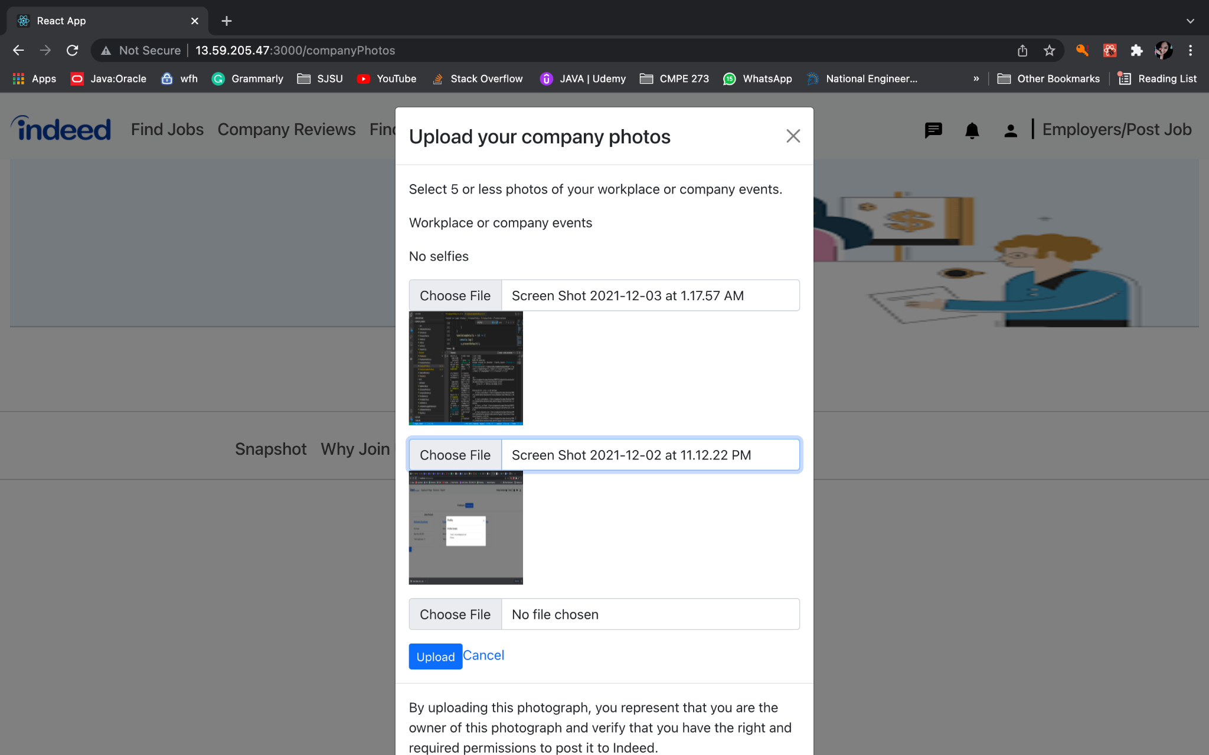

Jobs tab

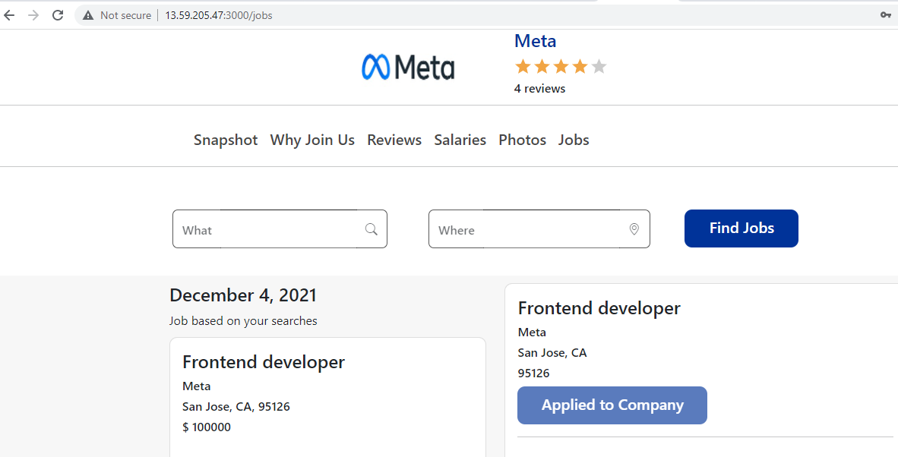

Find Salaries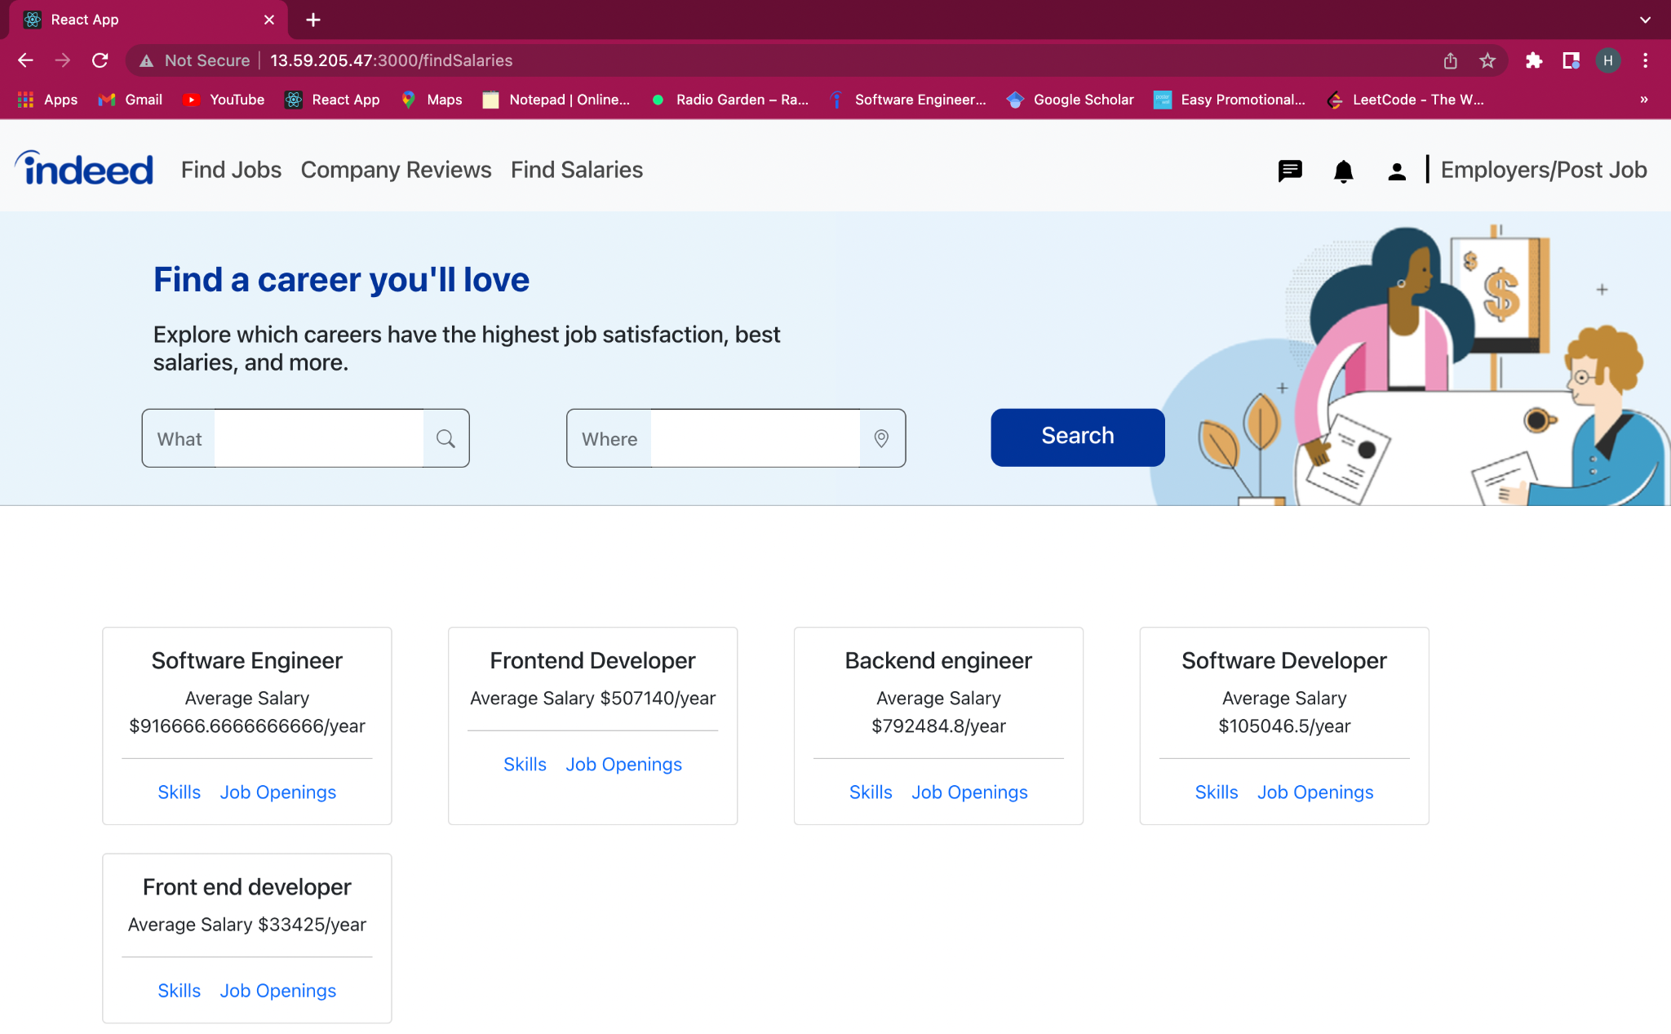

Find Salaries by Title

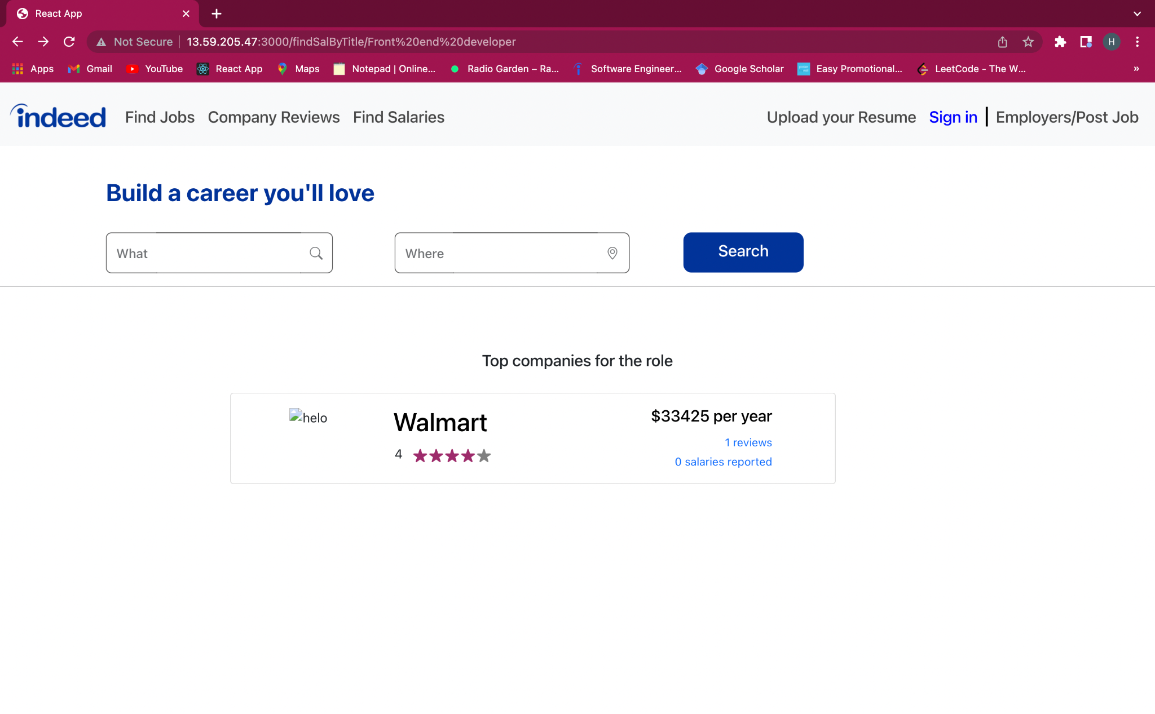

Reviews Tab

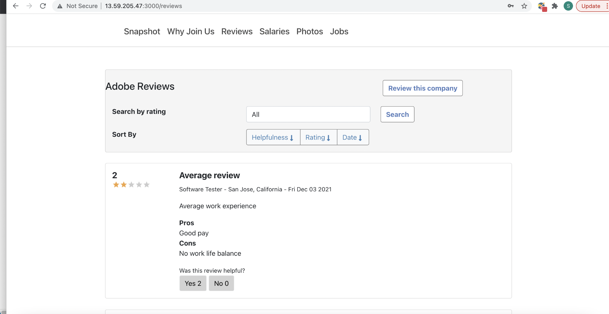

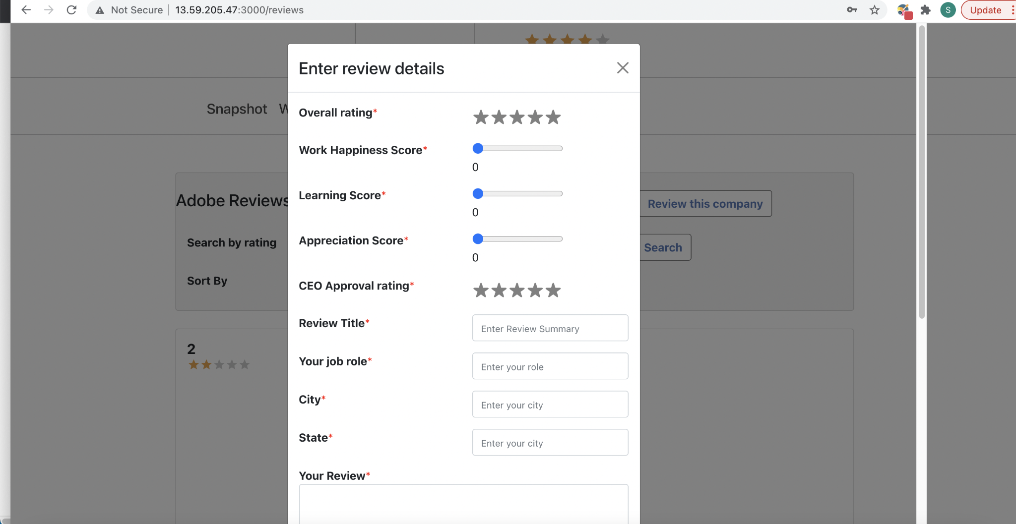

Salaries Tab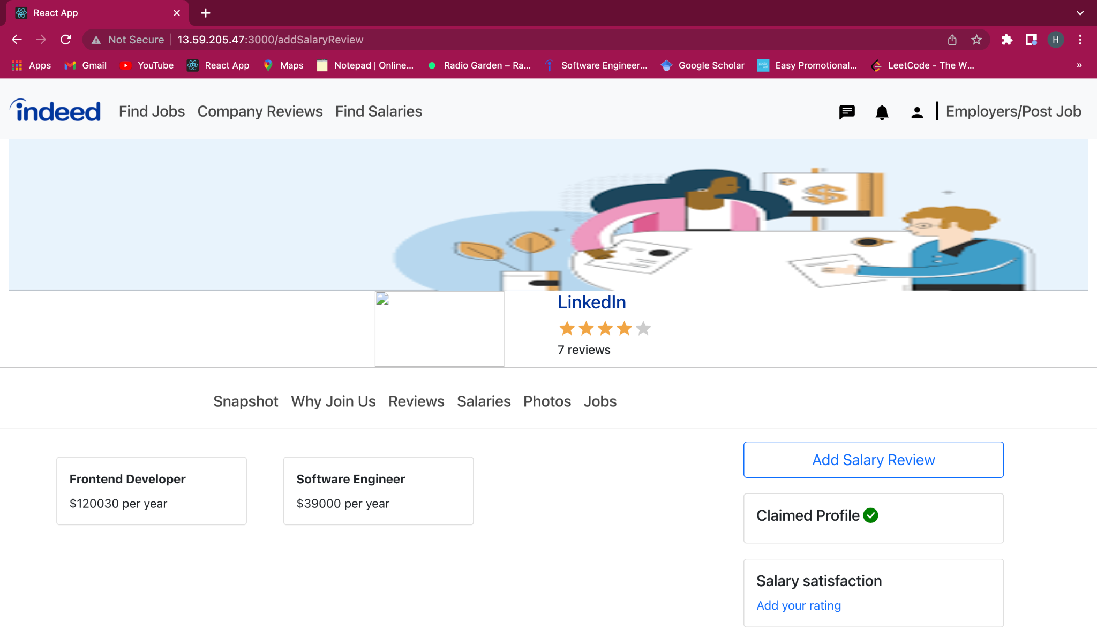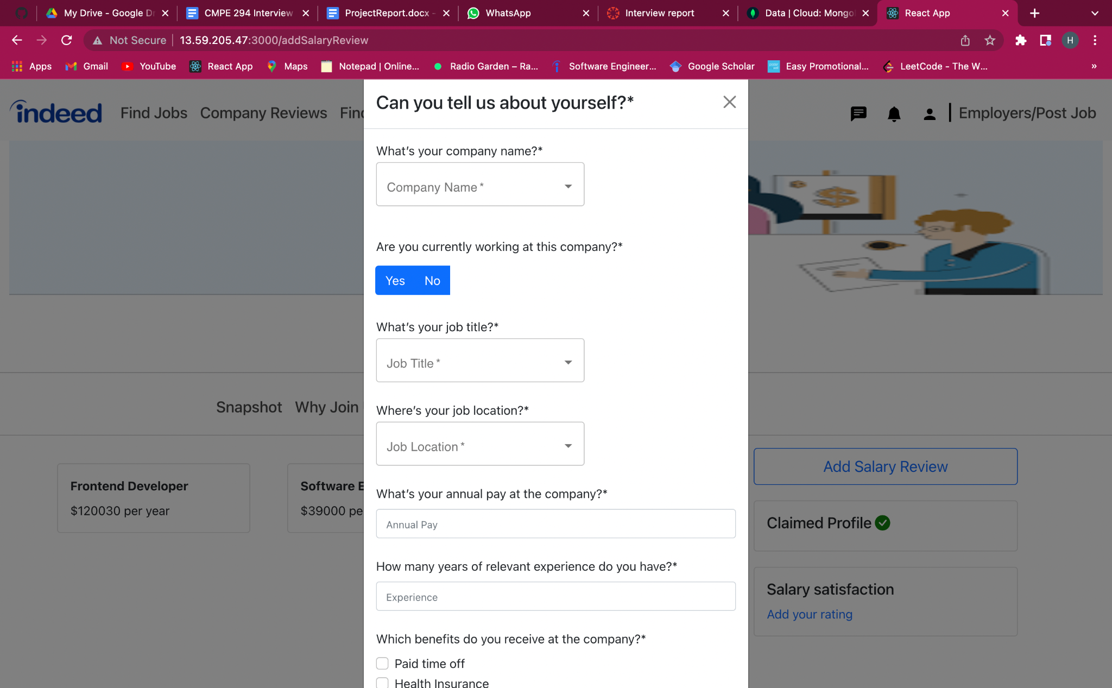

Company Reviews

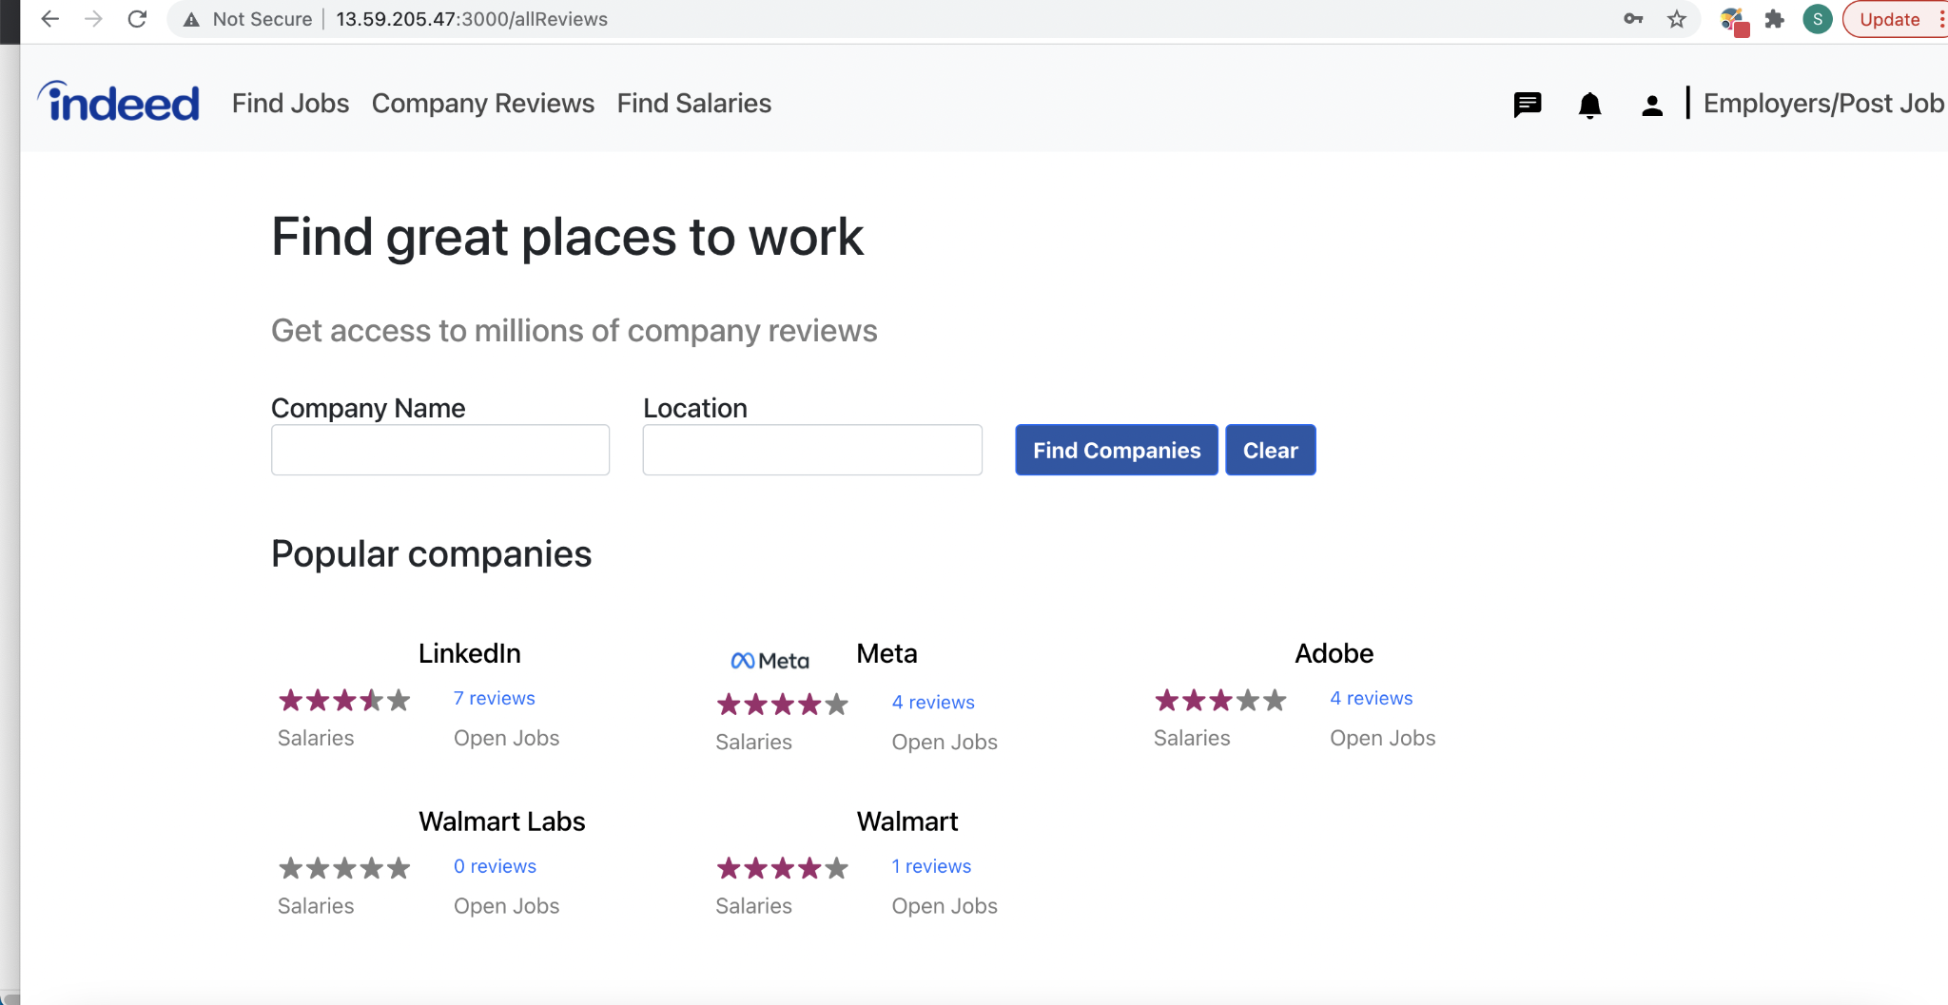

**Employer Pages:**

EmployerApplicant Page

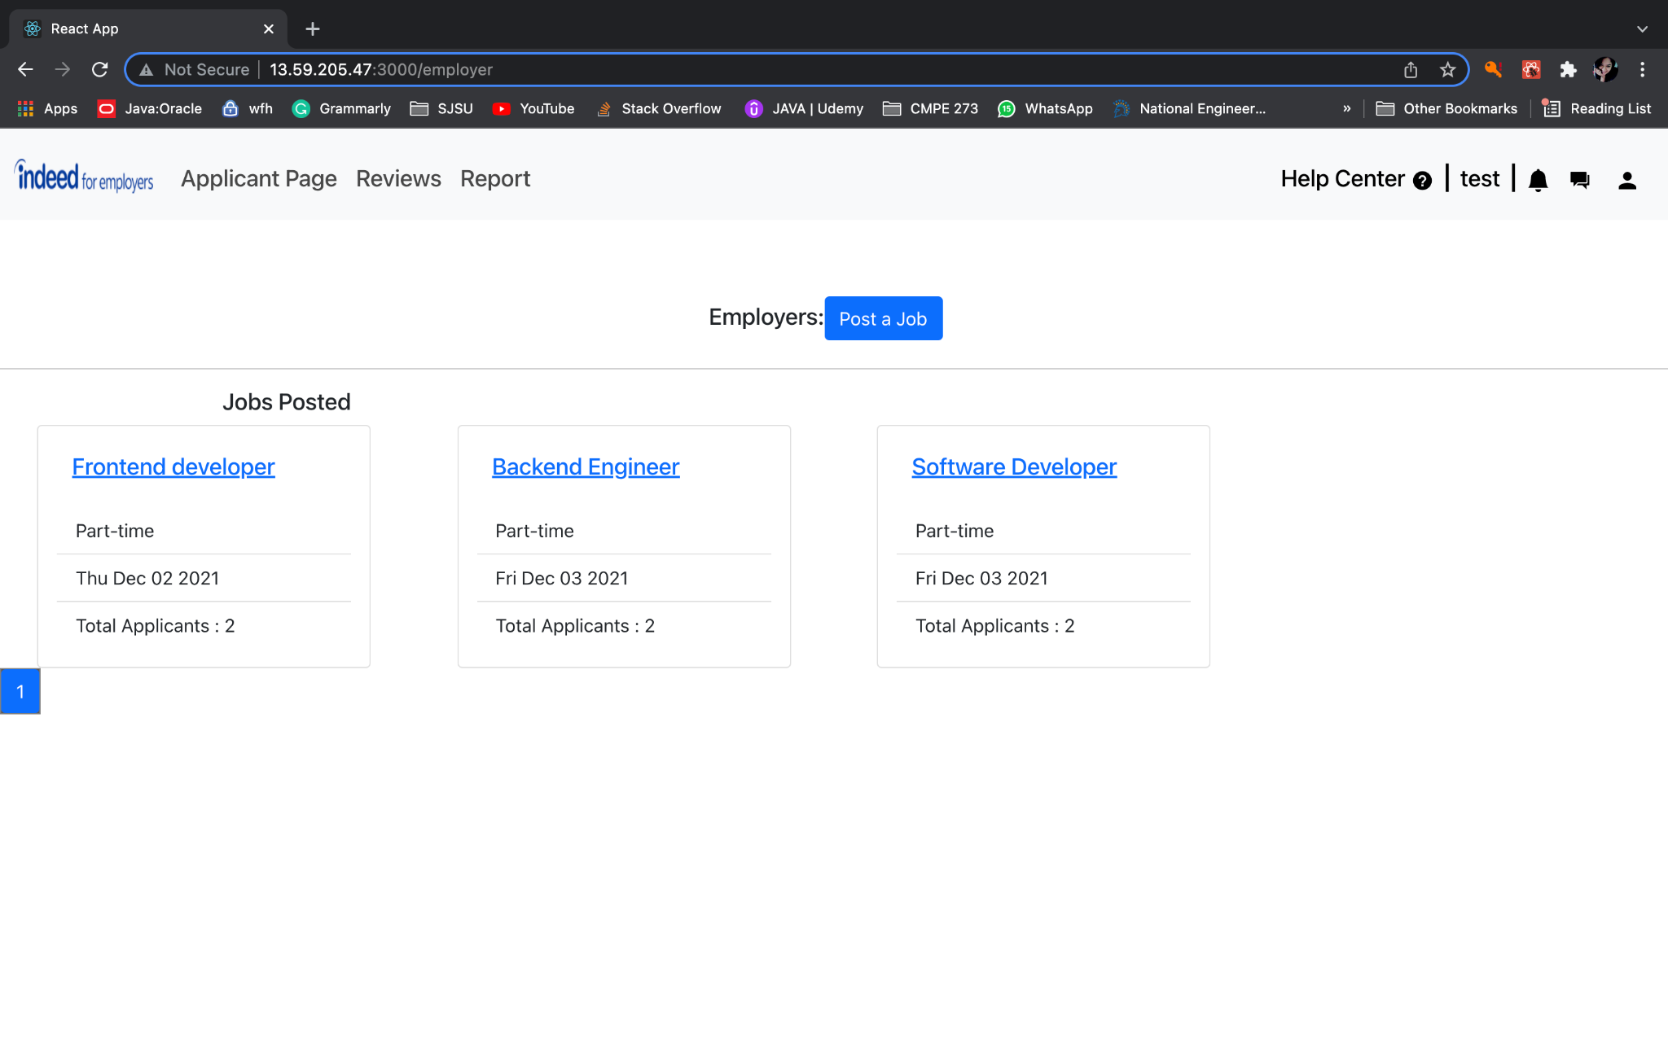

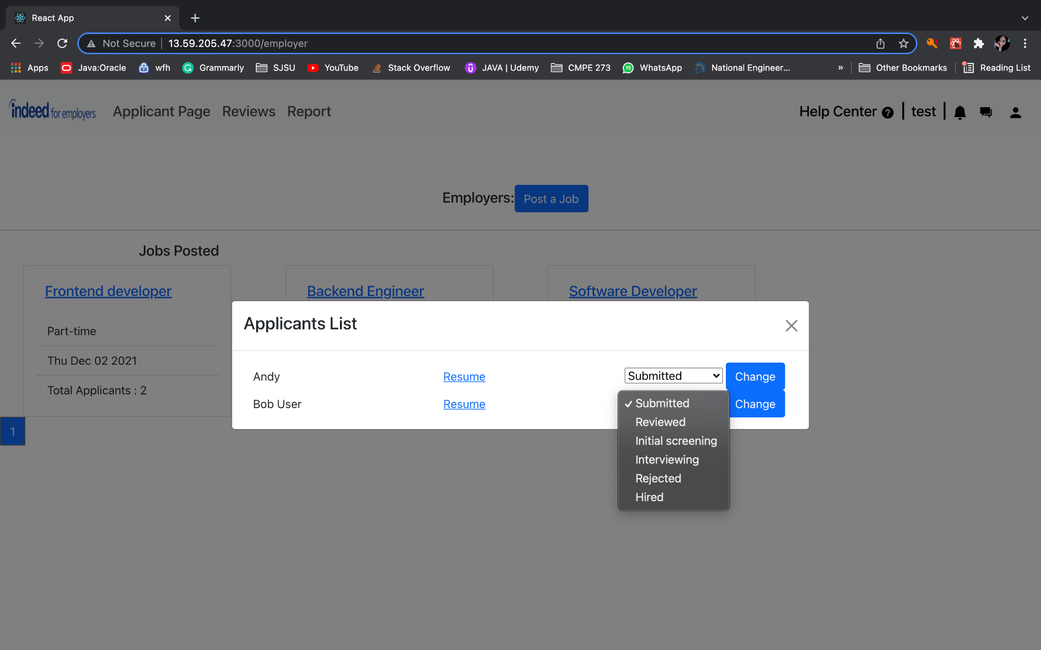

Employer Post Job

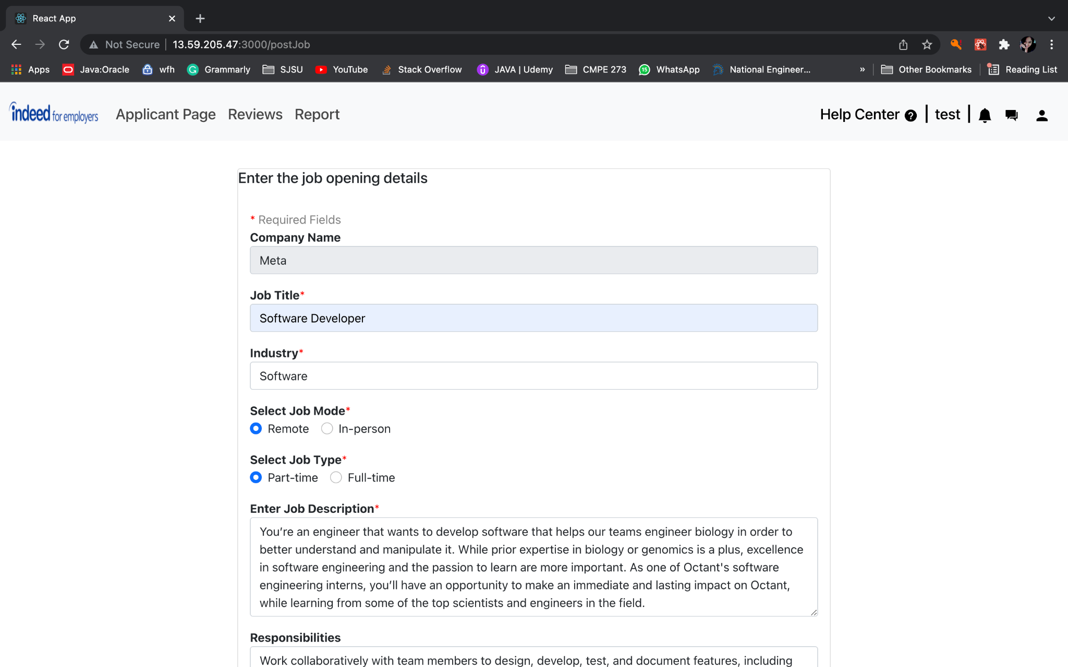

Employer Reviews Page

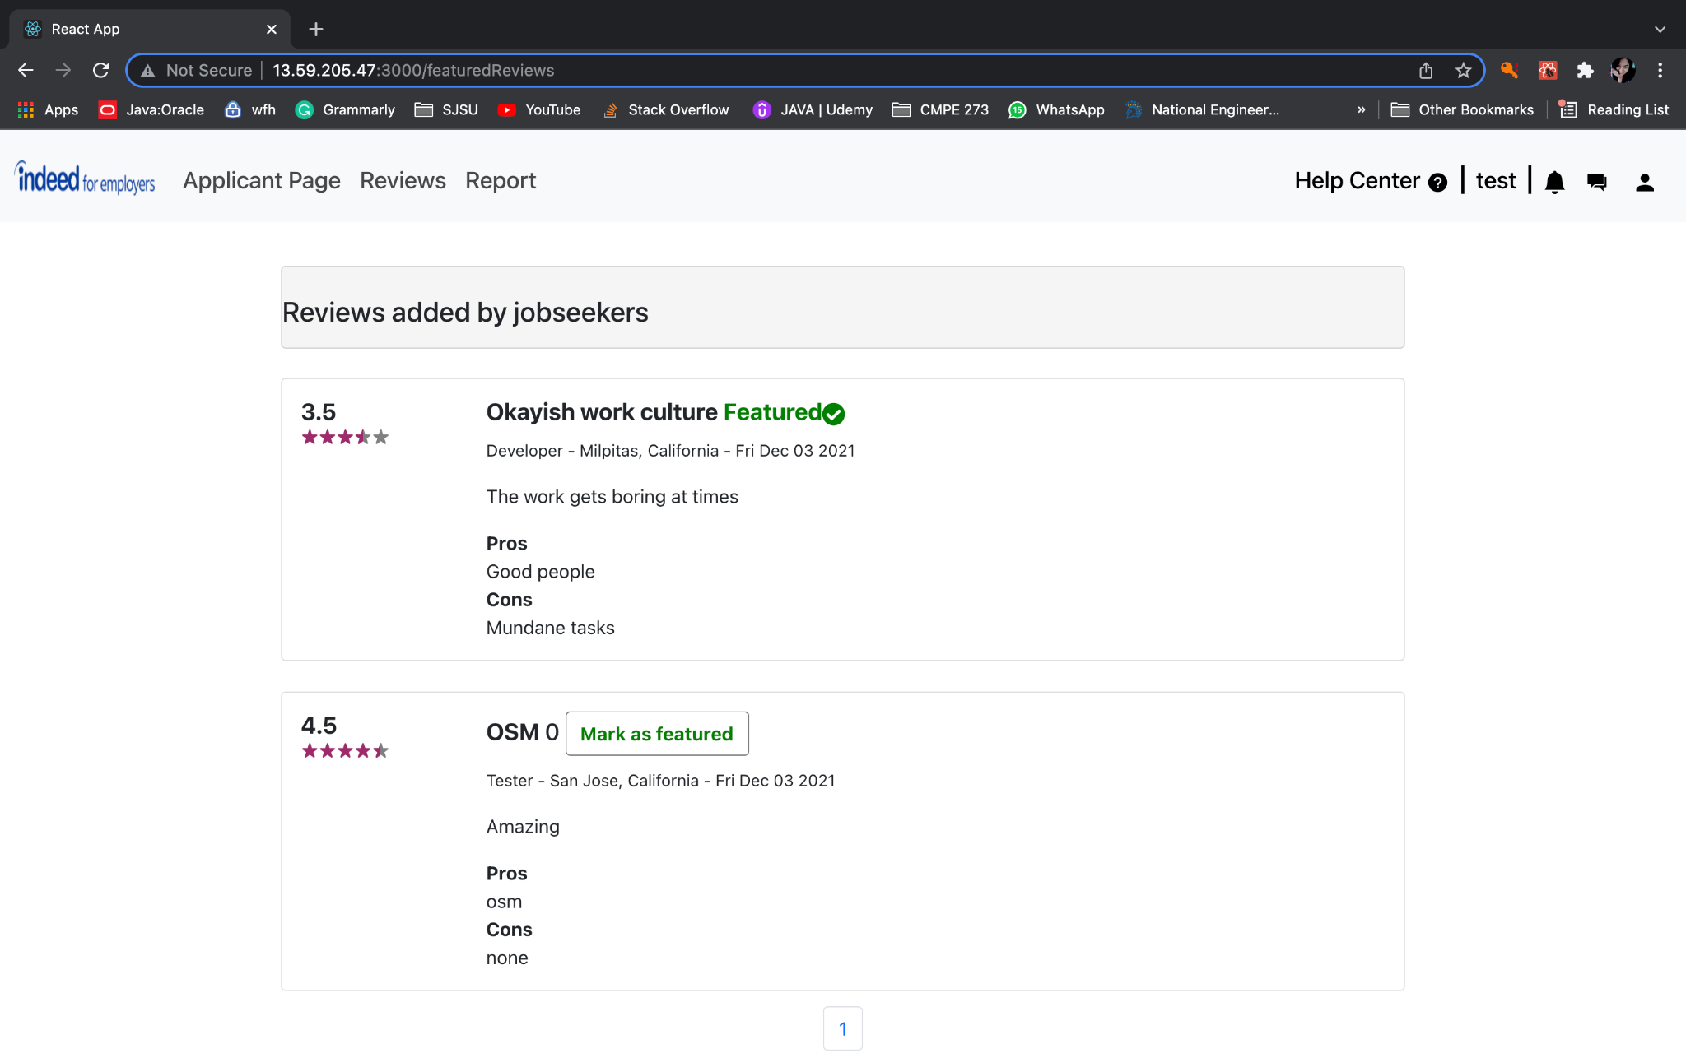

Employer Report

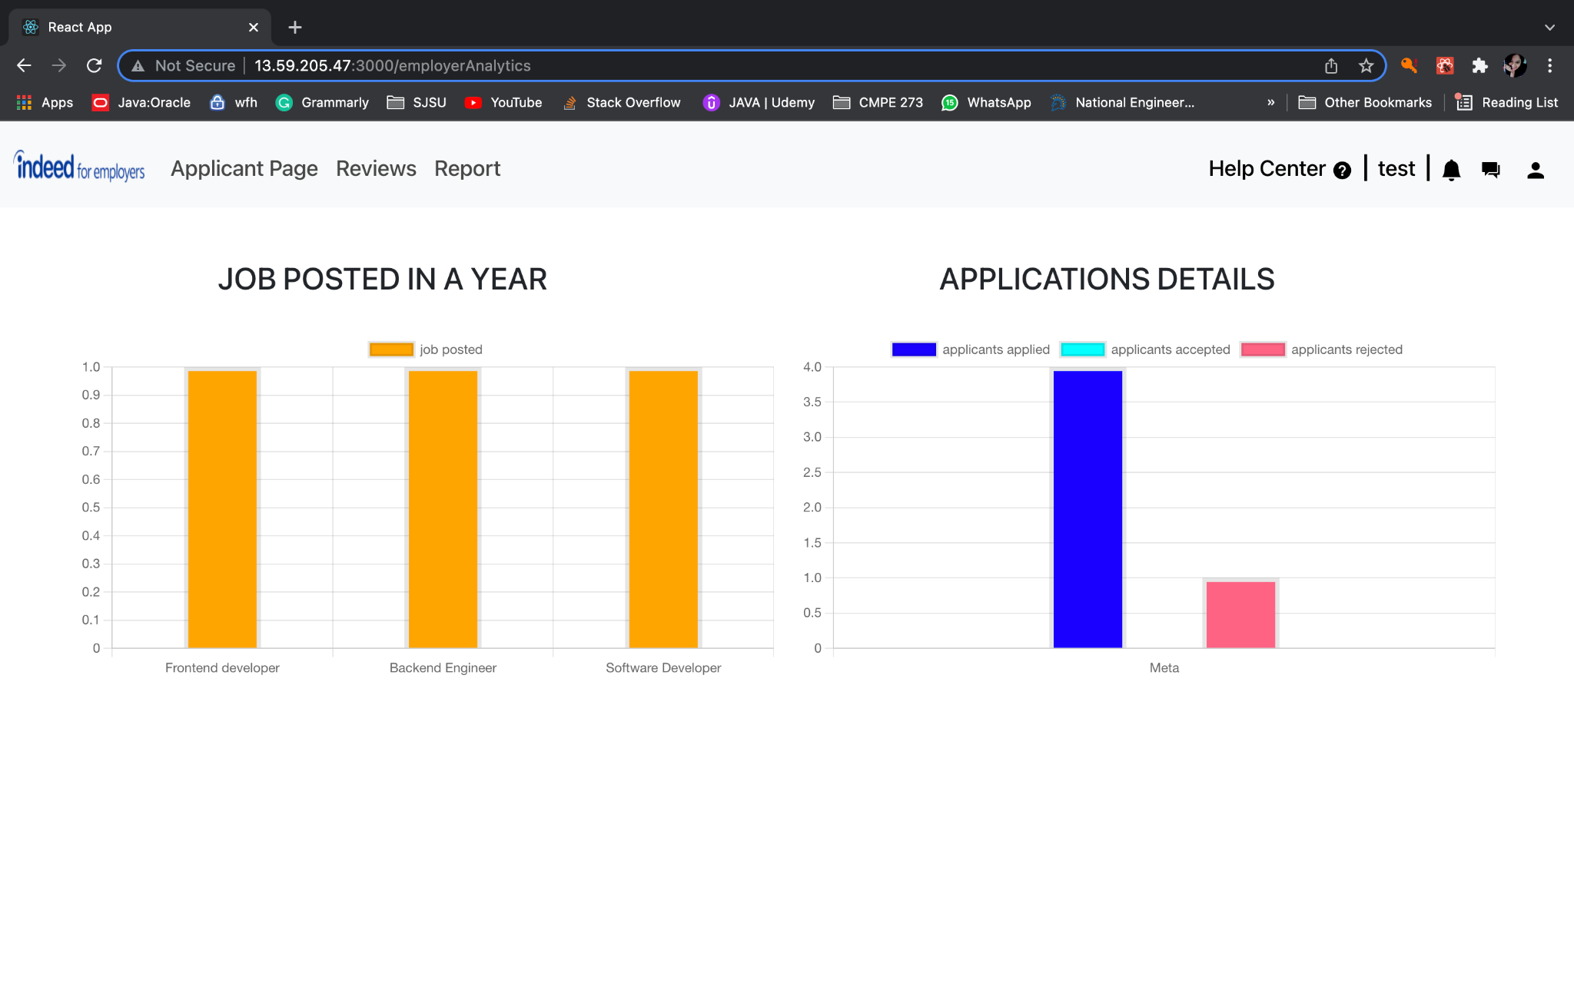

Employer and Company Profile

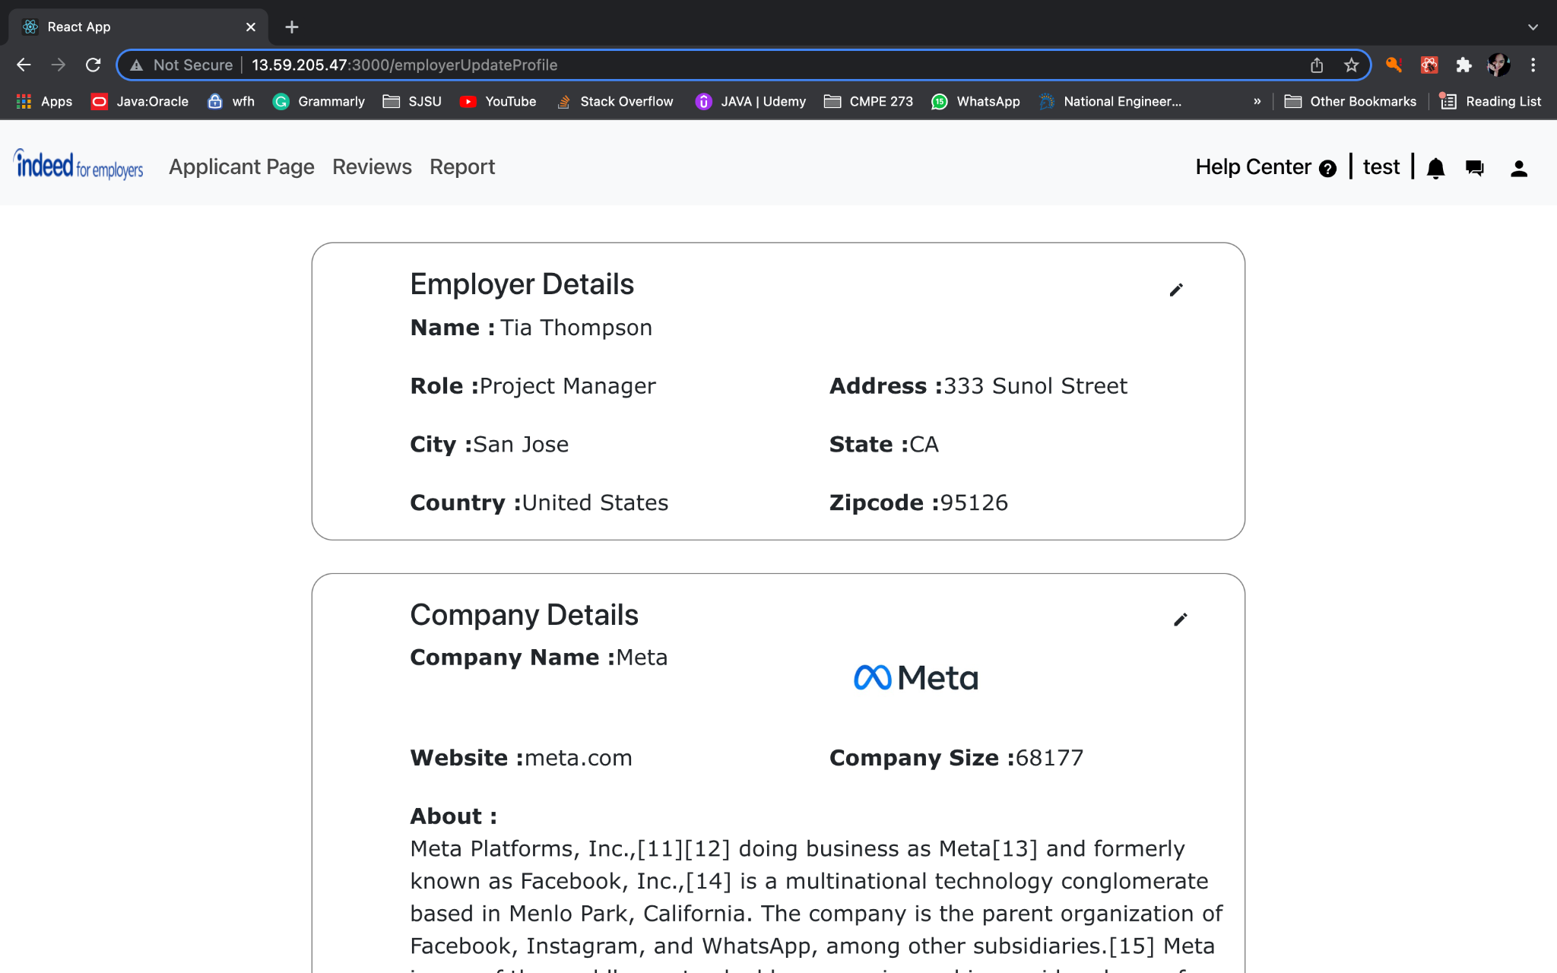

Employer Messenger Page

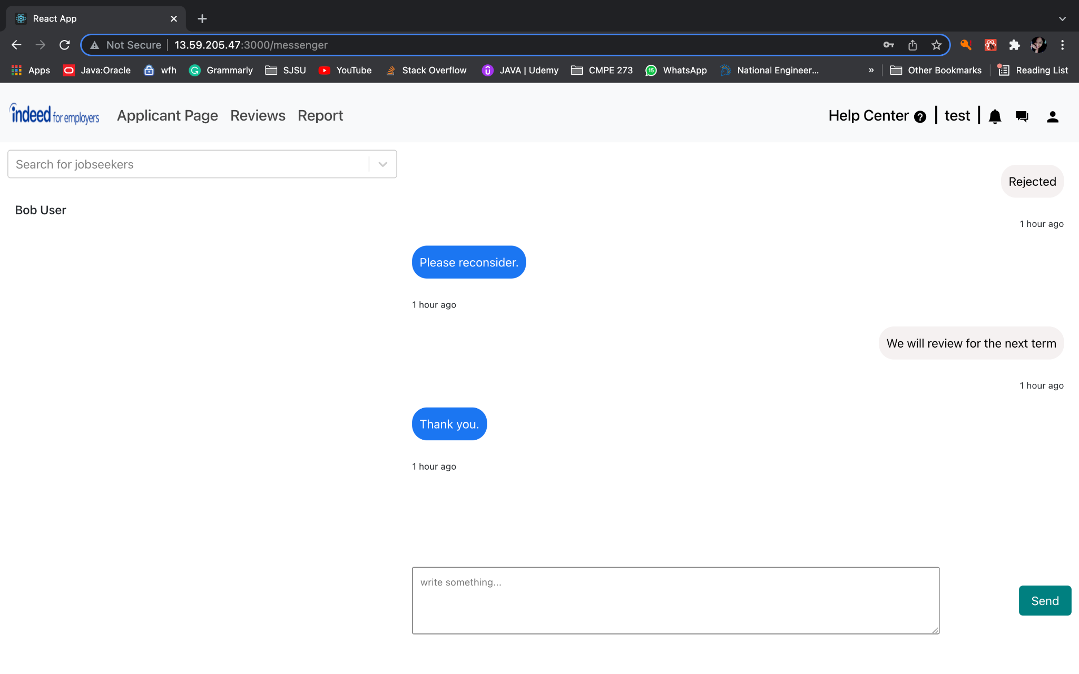

**Admin Pages :**

Admin Photos Page

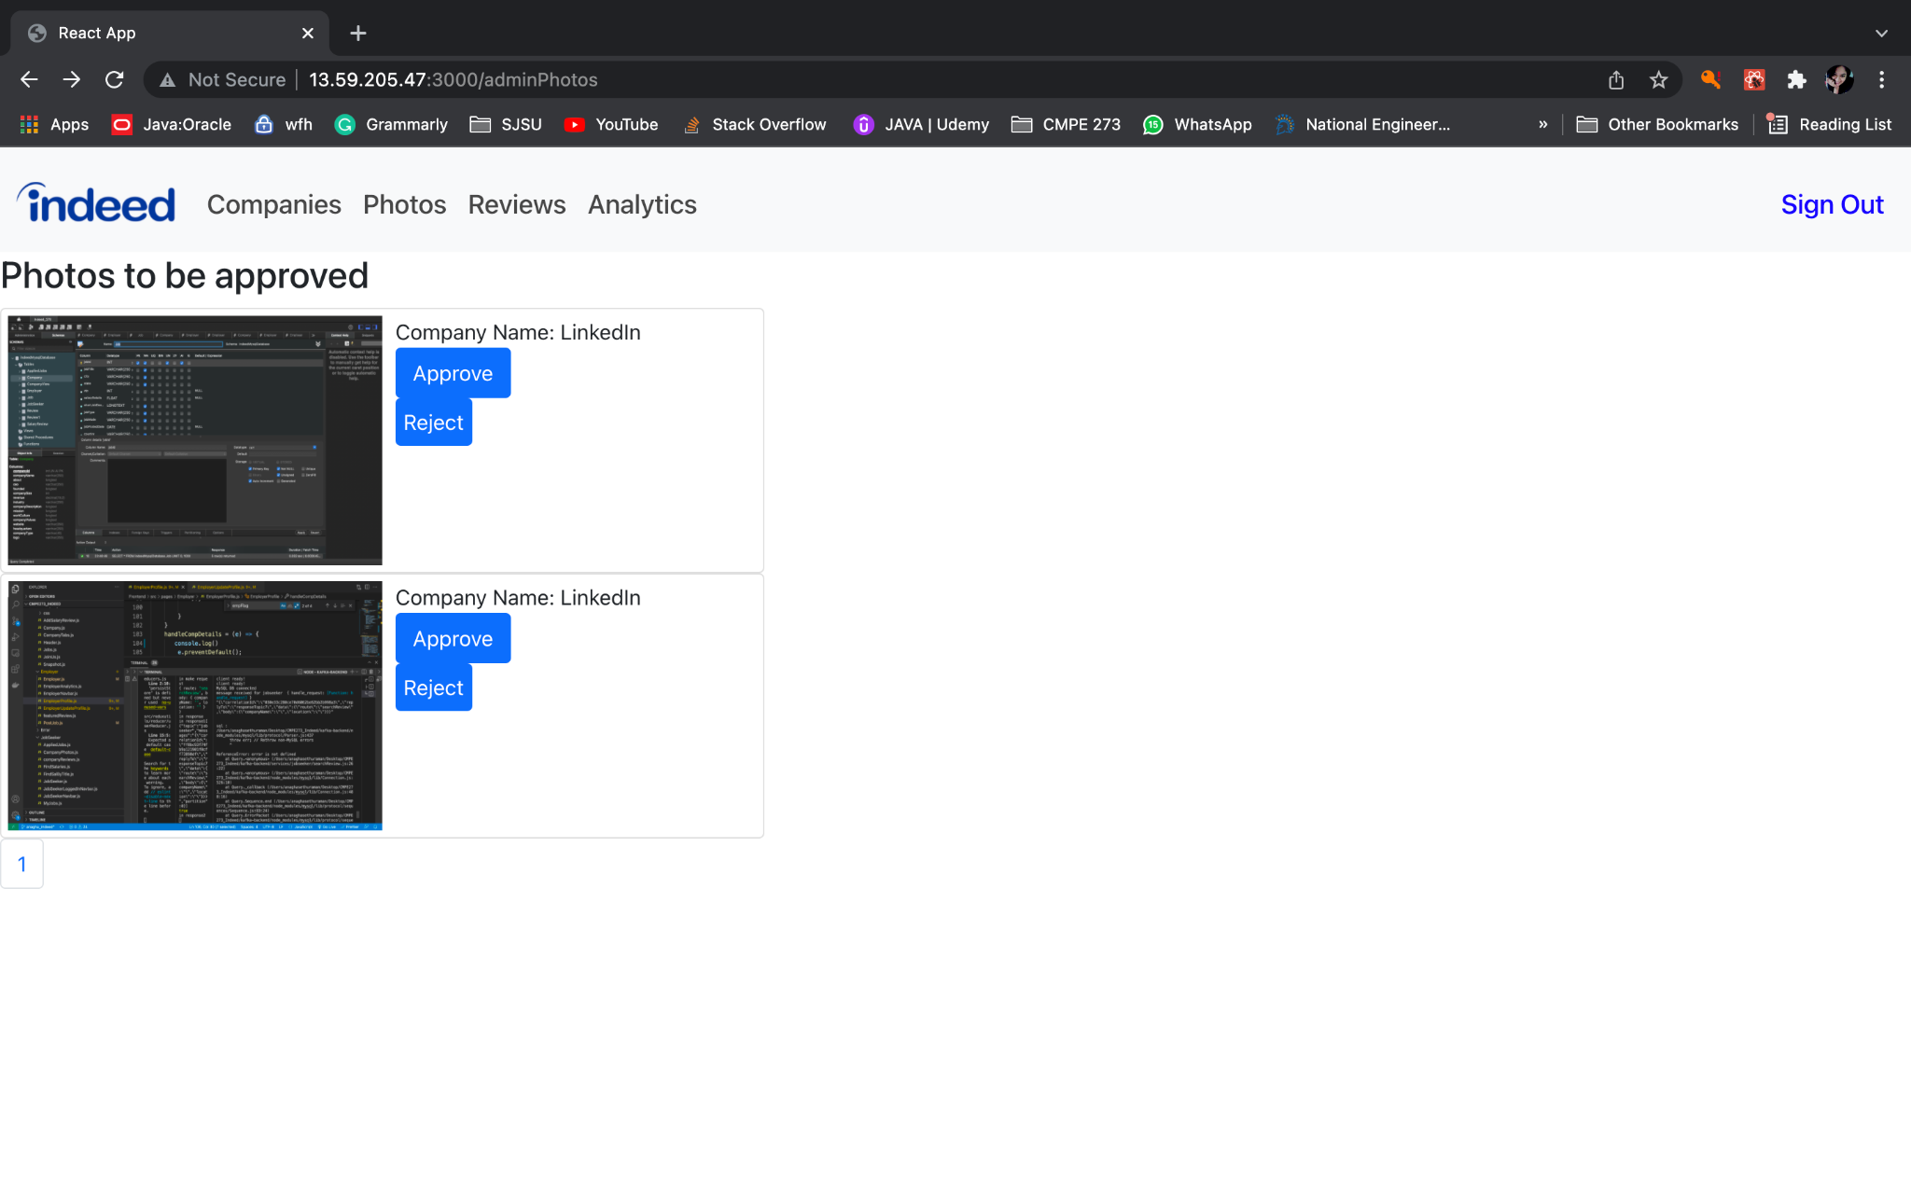

Admin Reviews Page

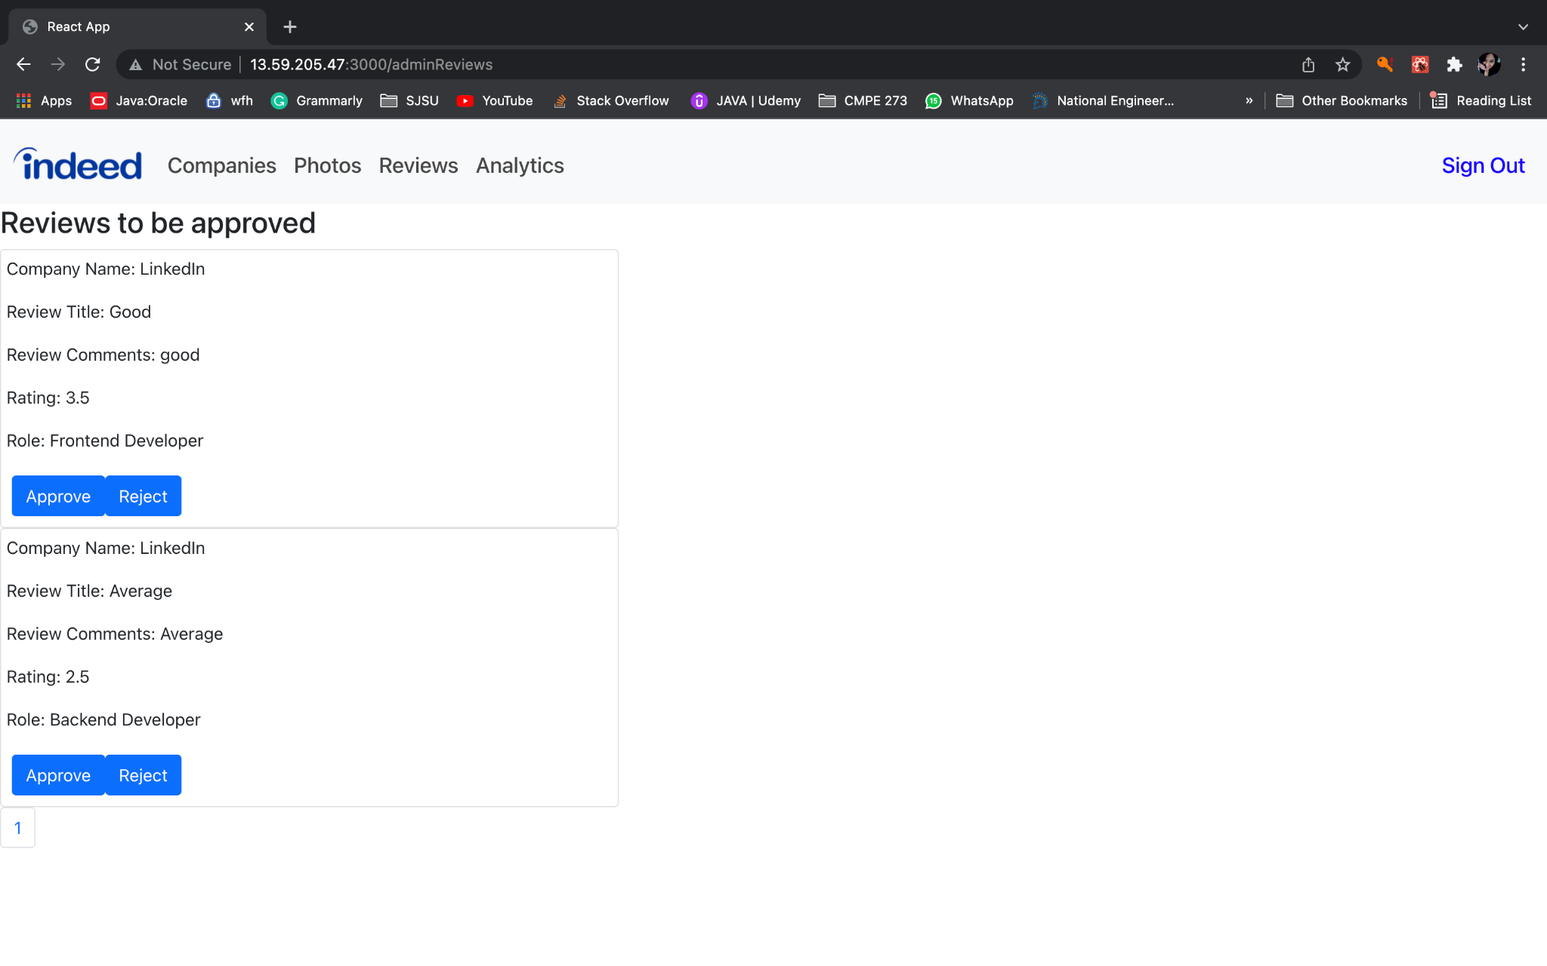

Admin Analytics Page

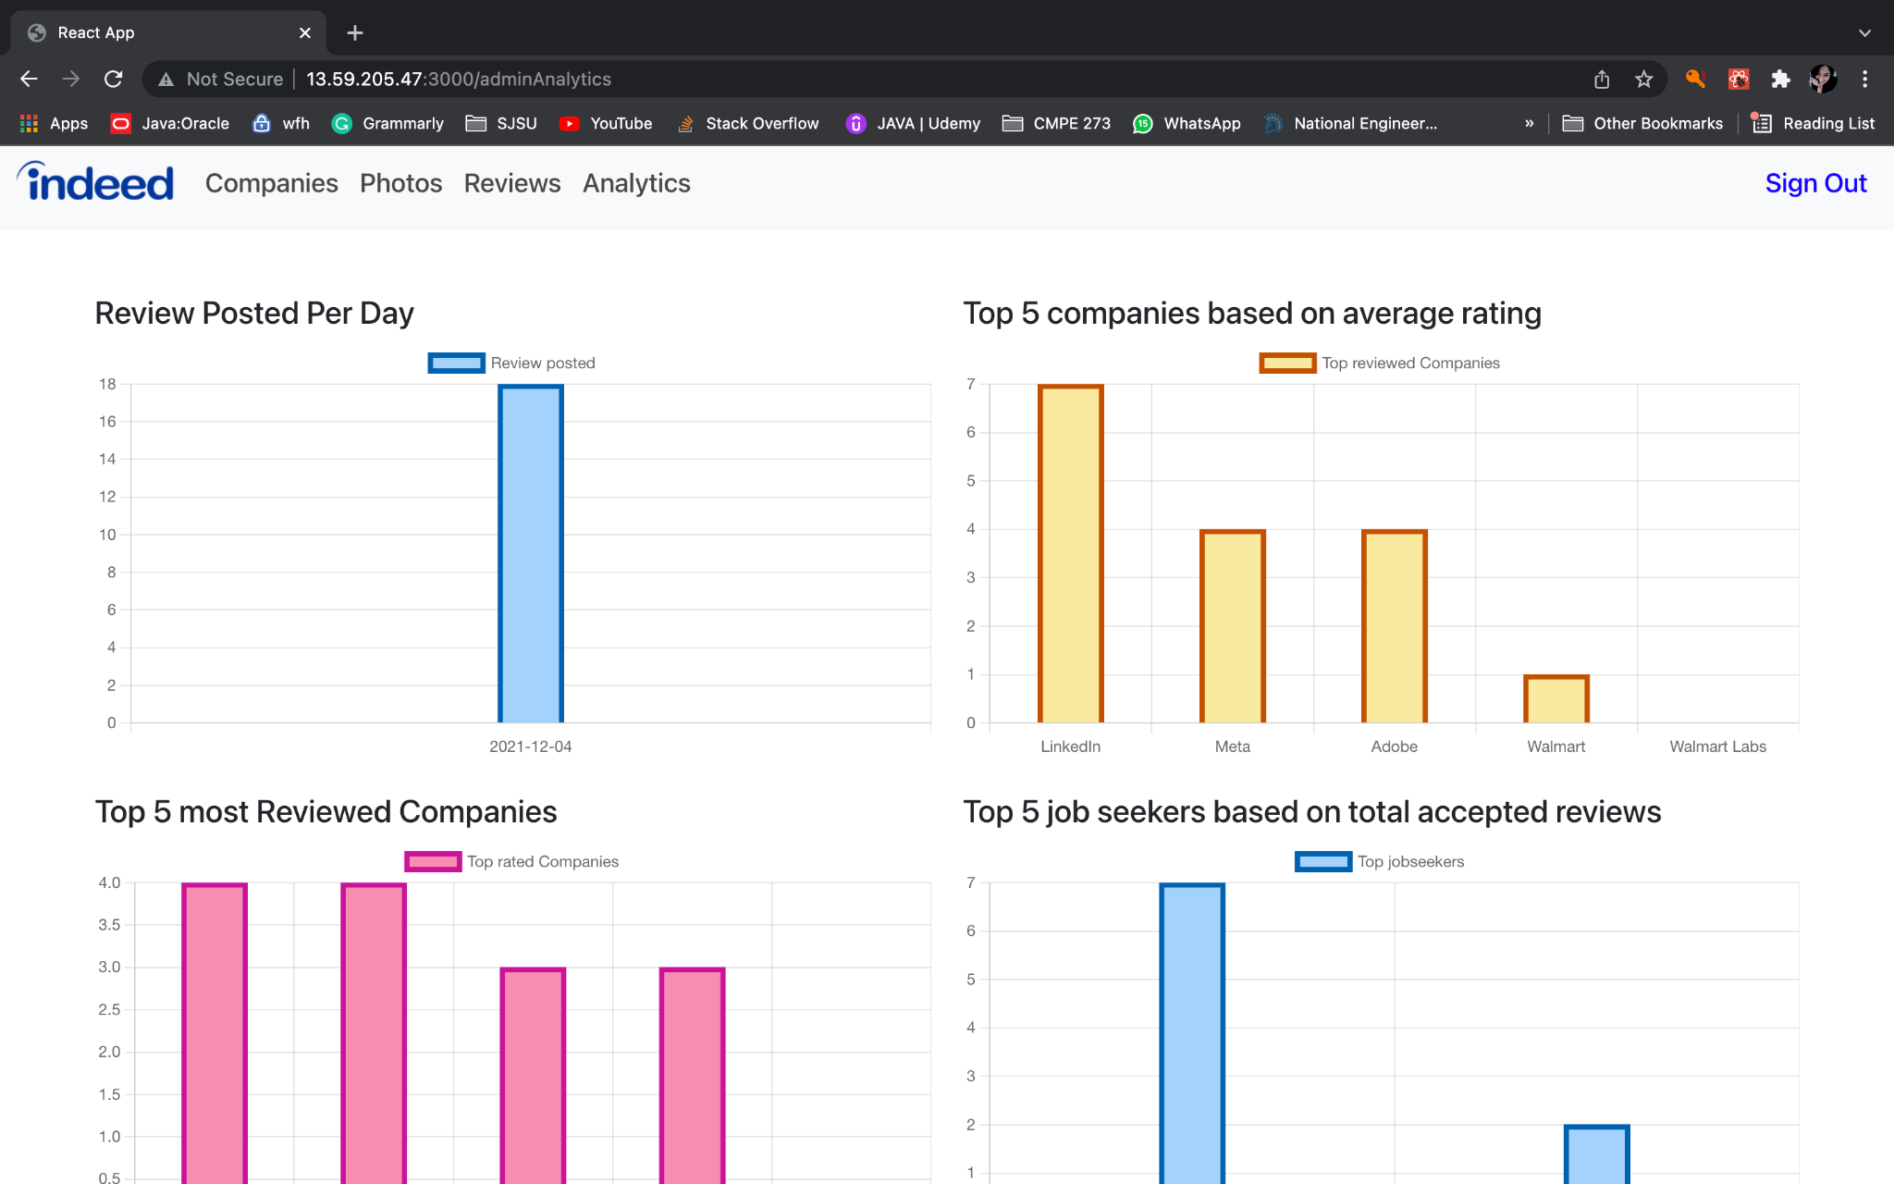

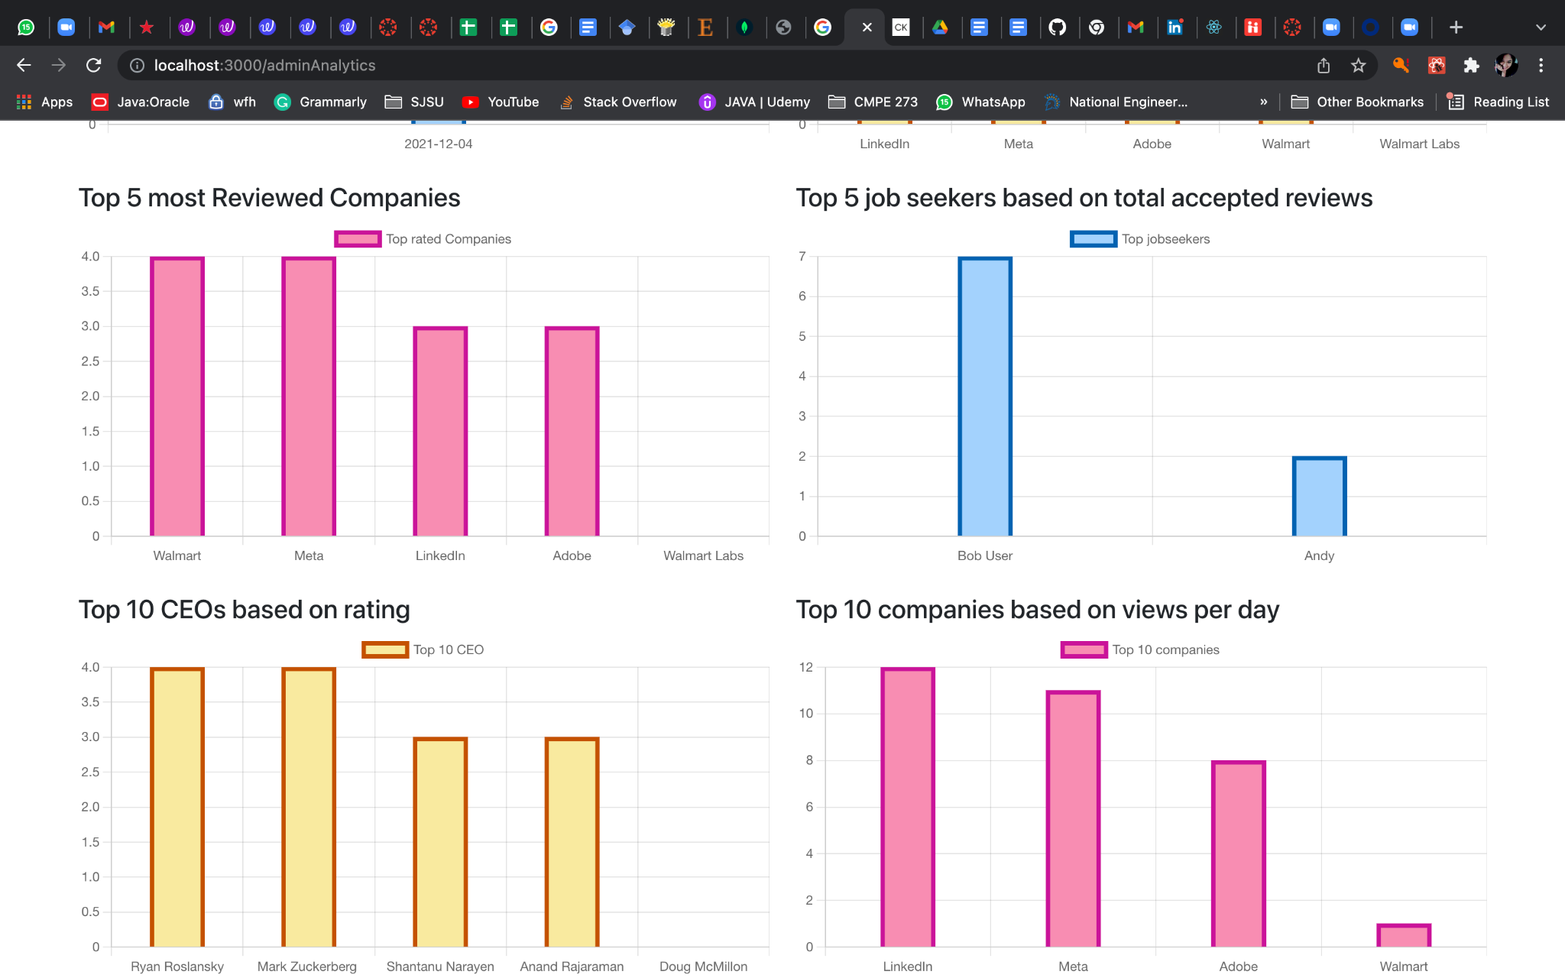

Admin Companies Page

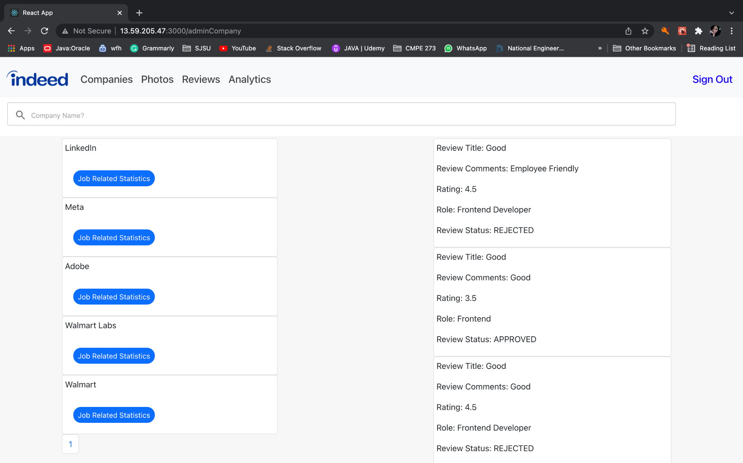

Admin - Job Statistics

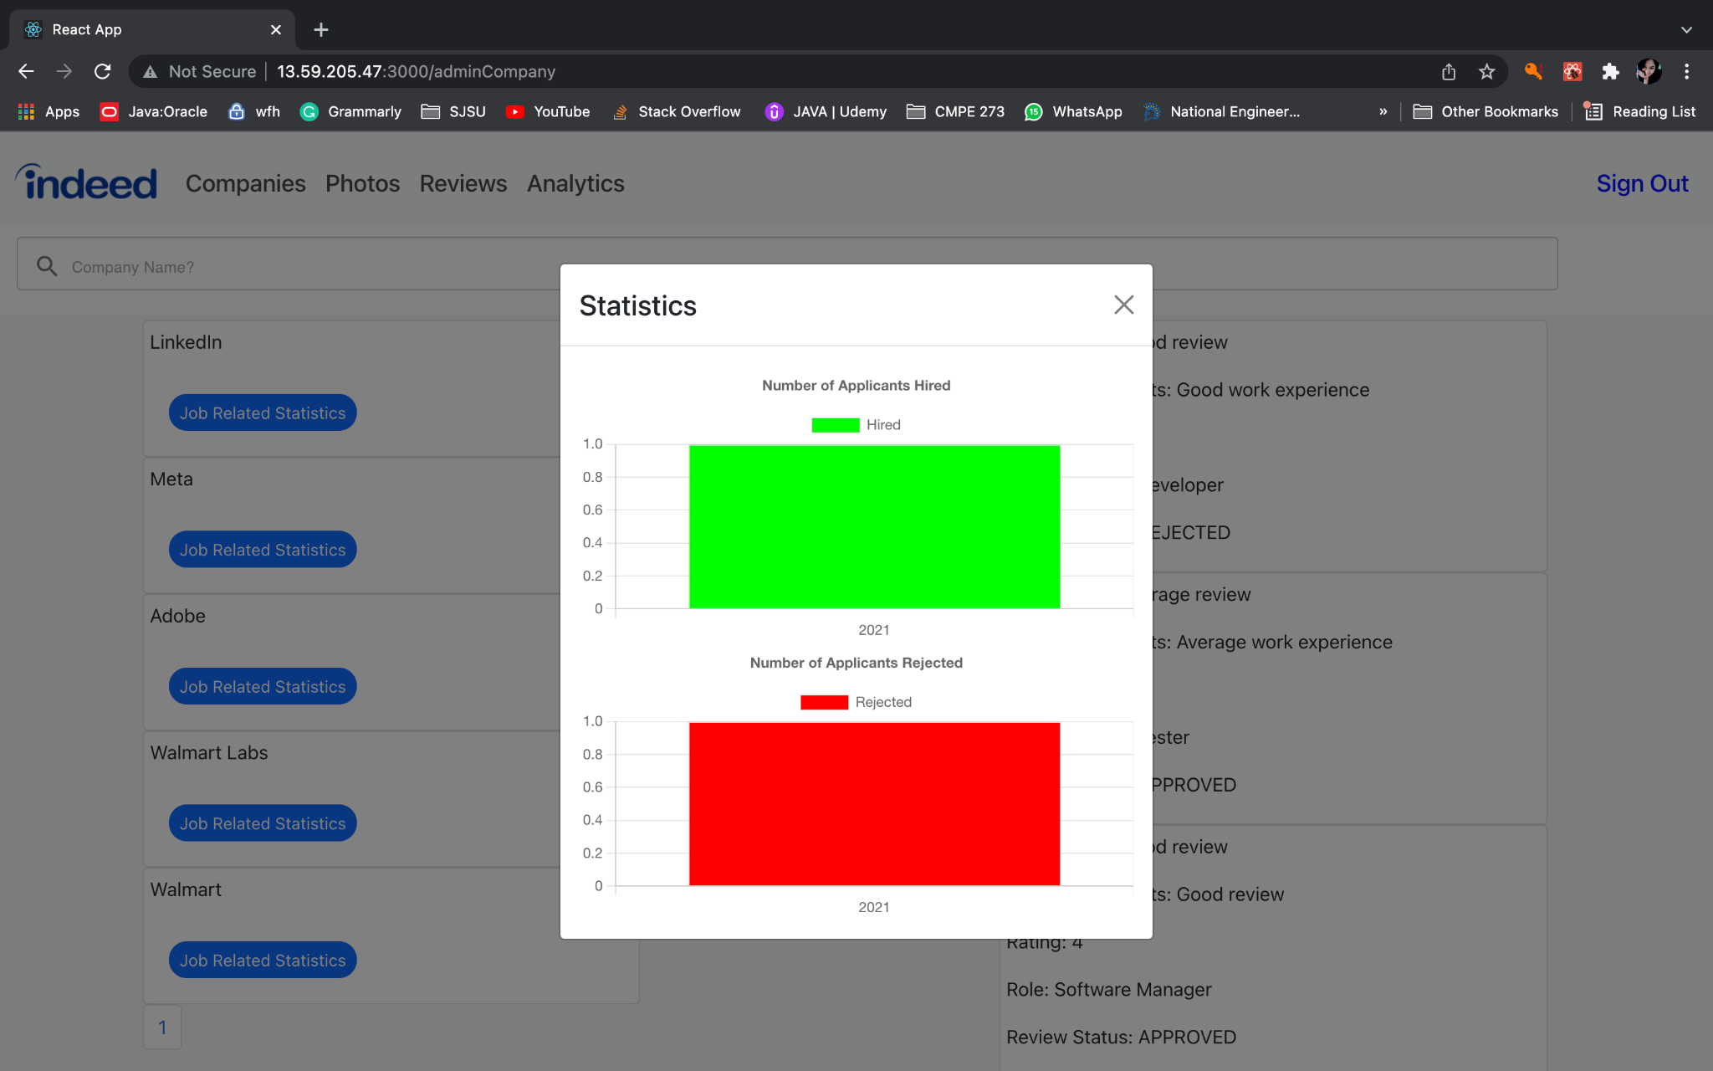

**Code listing of server implementation for entity objects**

**MongoDB models**

**Company.js**

const mongoose = require('mongoose')

const Schema = mongoose.Schema

const comSchema = new Schema({

  companyId: {

    type: Number,

    required: true,

  },

  companyName: {

    type: String,

    required: true,

  },

  logo: {

    type: String,

    required: false,

  },

  avgWorkHappinessScore: {

    type: Number,

  },

  avgLearningScore: {

    type: Number,

  },

  avgAppreciationScore: {

    type: Number,

  },

  noOfReviews: {

    type: Number,

  },

  companyAvgRating: {

    type: Number,

  },

  ceoAvgRating: {

    type: Number,

  },

})

const Company = mongoose.model('Company', comSchema)

module.exports = Company

**JobSeeker.js**

const mongoose = require('mongoose');

const Schema = mongoose.Schema;

const jsSchema = new Schema({

    jobSeekerId: {

        type: Number,

        required: true

    },

    resumeUrl: {

        type: String

    },

    jobPreference: {

        type: Schema.Types.Mixed,

default: {}

    },

    savedJobs: [{

        type: Array,

    }]

}, {minimize: false});

const JobSeeker = mongoose.model('JobSeeker',jsSchema);

module.exports = JobSeeker;

**Photo.js**

const mongoose = require('mongoose');

const PhotoSchema = mongoose.Schema({

  jobSeekerId: {

    type: Number,

    required: true

  },

  companyId: {

    type: Number,

    required: true

  },

  companyName: {

    type: String,

    required: true

  },

  imageLocation: {

    type: String,

    required: true

  },

  photoAdminReviewedStatus: {

    type: String,

    required: true

  }

});

module.exports = mongoose.model('Photo', PhotoSchema);

**Conversation.js**

const mongoose = require('mongoose')

const ConversationSchema = mongoose.Schema({

    members: {

        type: Array,

        required: true

    },

},

    { timestamps: true }

);

module.exports = mongoose.model('Conversation', ConversationSchema);

**Message.js**

const mongoose = require('mongoose')

const MessageSchema = mongoose.Schema({

    conversationId: {

        type: String

    },

    sender: {

        type: String

    },

    messageText: {

        type: String

    }

},

    { timestamps: true }

);

module.exports = mongoose.model('Message', MessageSchema);

**Code listing of server implementation of the security and session objects**

"use strict";

var JwtStrategy = require("passport-jwt").Strategy;

var ExtractJwt = require("passport-jwt").ExtractJwt;

const passport = require("passport");

var { secret } = require("./config");

const conn = require("../config/mysql_connection");

const admin = {

  name: "admin user",

  email: "admin@indeed.com",

  password: "admin",

  id: "adminid_1",

};

// Setup work and export for the JWT passport strategy

function auth() {

  var opts = {

    jwtFromRequest: ExtractJwt.fromAuthHeaderWithScheme("JWT"),

    secretOrKey: secret,

  };

  passport.use(

    new JwtStrategy(opts, (jwt_payload, callback) => {

      const accountType = jwt_payload.accountType;

      console.log("accountType" + jwt_payload.accountType);

      if ("JobSeeker" === accountType) {

        console.log("id" + jwt_payload.id);

        findJobSeekerById(jwt_payload.id, (err, results) => {

          if (err) {

            console.log("err: " + err);

            return callback(err, false);

          }

          if (results) {

            console.log("results");

            callback(null, results[0]);

          } else {

            callback(null, false);

          }

        });

      } else if ("Employer" === accountType) {

        findEmployerById(jwt_payload.id, (err, results) => {

          if (err) {

            return callback(err, false);

          }

          if (results) {

            callback(null, results[0]);

          } else {

            callback(null, false);

          }

        });

      }

      else if ("Admin" === accountType && jwt_payload.id === admin.id) {

        callback(null, admin);

      }

      else {

        callback(null, false);

      }

    })

  );

}

function findJobSeekerById(id, callback) {

  return conn.query("SELECT * from JobSeeker WHERE id = ?", [id], callback);

}

function findEmployerById(id, callback) {

  return conn.query("SELECT * from Employer WHERE id = ?", [id], callback);

}

exports.auth = auth;

exports.checkAuth = passport.authenticate("jwt", { session: false });

**Code listing of main server code**

**Backend server.js**

const conn2 = require('./config/mongo_connection')

const conn1 = require('./config/mysql_connection')

const express = require('express')

const app = express()

const session = require('express-session')

var cors = require('cors')

app.use(cors())

// Connect to MySQL database

conn1.mysqlCon

// Connect to MongoDB

conn2()

// Init Middleware

app.use(express.json({ extended: false }))

app.use(

  session({

    secret: 'secret',

    resave: true,

    saveUninitialized: true,

  }),

)

//Define all the models

require('./models/JobSeeker')

require('./models/Company')

require('./models/Photo')

require('./models/Conversation')

require('./models/Message')

//Define all the routes

app.use(require('./routes/loginRoute'))

app.use(require('./routes/companyRoute'))

app.use(require('./routes/postNewJob'))

app.use(require('./routes/signupRoute'))

app.use(require('./routes/jobSeekerHome'))

app.use(require('./routes/jobs'))

app.use(require('./routes/uploadPhotos'))

app.use(require('./routes/getAllPhotos'))

app.use(require('./routes/getJobSeekerPhotos'))

app.use(require('./routes/adminPhotos'))

app.use(require('./routes/getEmployerProfile'))

app.use(require('./routes/editEmployerDetails'))

app.use(require('./routes/addEmployerDetails'))

app.use(require('./routes/editCompanyDetails'))

app.use(require('./routes/salaryReviewRoute'))

app.use(require('./routes/adminReviews'))

app.use(require('./routes/companyReviews'))

app.use(require('./routes/findSalary'))

app.use(require('./routes/addCompanyDetails'))

app.use(require("./routes/getCompanyDetails"))

app.use(require("./routes/addCompanyIdToEmployer"))

app.use(require("./routes/employerAnalytics"))

app.use(require("./routes/jobSeekerProfileRoute"))

app.use(require("./routes/employerFeaturedReviews"))

app.use(require("./routes/getPostedJobs"))

app.use(require("./routes/getApplicantsName"))

app.use(require("./routes/getJobSeekerProfile"))

app.use(require("./routes/getJobSeekerResume"))

app.use(require("./routes/allCompanyReviews"))

app.use(require("./routes/adminAnalytics"))

app.use(require("./routes/updateJobSeekerStatus"))

app.use(require("./routes/getAllReviews"))

app.use(require("./routes/conversationRoute"))

app.use(require("./routes/messageRoute"))

app.use(require("./routes/testRoute"))

app.use(require("./routes/reviewsByProfile"))

app.use(require("./routes/getJobSeekerPhotos"))

app.use(require("./routes/myjobs"));

const PORT = process.env.PORT || 5000

//Server code will be running on port 5000

app.listen(PORT, () => console.log(`Server started on port ${PORT}`))

**Kafka-backend server.js**

var connection =  new require('./kafka/Connection');

const conn2 = require('./config/mongo_connection')

const conn1 = require('./config/mysql_connection')

// Connect to MySQL database

conn1.mysqlCon

// Connect to MongoDB

conn2()

//Define all the models

require('./models/JobSeeker')

require('./models/Company')

require('./models/Photo')

require('./models/Conversation')

require('./models/Message')

const jobseeker = require('./services/jobseeker');

const employer = require('./services/employer');

const company = require('./services/company');

const admin = require('./services/admin');

const user = require('./services/user');

function handleTopicRequest(topic_name, fname) {

  //var topic_name = 'root_topic';

  var consumer = connection.getConsumer(topic_name)

  var producer = connection.getProducer()

  console.log('server is running ')

  consumer.on('message', function (message) {

    console.log('message received for ' + topic_name + ' ', fname)

    console.log(JSON.stringify(message.value))

    var data = JSON.parse(message.value)

    fname.handle_request(data.data, function (err, res) {

      console.log('after handle', res)

      var payloads = [

        {

          topic: data.replyTo,

          messages: JSON.stringify({

            correlationId: data.correlationId,

            data: res,

          }),

          partition: 0,

        },

      ]

      console.log('sending response' + JSON.stringify(payloads))

      producer.send(payloads, function (err, data) {

        console.log(data)

      })

      return

    })

  })

}

// Add your TOPICs here

//first argument is topic name

//second argument is a function that will handle this topic request

handleTopicRequest("jobseeker",jobseeker);

handleTopicRequest("employer",employer);

handleTopicRequest("admin",admin);

handleTopicRequest("company",company);

handleTopicRequest("user",user);

**Code listing of database access or connection**

**MongoDB connection**

const mongoose = require("mongoose");

const config = require("./config.js");

const db = config.mongoURI;

const connectDB = async () => {

  try {

    await mongoose.connect(db, {

      useNewUrlParser: true,

      useUnifiedTopology: true,

      maxPoolSize: 10

    });

    console.log("MongoDB Connection Established Successfully");

  } catch (err) {

    console.error(err.message);

    process.exit(1);

  }

};

module.exports = connectDB;

**MySQL connection**

const mysql = require('mysql');

const mysqlCon = mysql.createPool({

  host: 'indeedmysql273database.c2oqhcbfsxrv.us-west-2.rds.amazonaws.com',

  user: 'xx',

  password: 'xxx',

  database:'indeedMysqlDatabase',

  port: 3306

});

mysqlCon.getConnection(function(err){

  if(err) {

    console.log(err.message)

  };

  console.log("MySQL DB connected")

})

module.exports = mysqlCon;

**Code listing of mocha test**

//test.js

var supertest = require("supertest");

var app = require("../server");

var server = supertest.agent("http://localhost:5000");

var chai = require("chai");

chai.use(require("chai-http"));

var assert = require('assert');

describe('Indeed', function () {

describe("Employer Details", () => {

it('Applicants name List',(done) => {

server.post("/getApplicantsName")

.send({ jobId:25,companyId:68 })

.then(function (res) {

assert.equal(res.status, 200);

done();

})

.catch(done);

});

it('Get Employer Profile',(done) => {

server.post("/getEmployerProfile")

.send({empid:21})

.then(function (res) {

assert.equal(res.status, 200);

done();

})

.catch(done);

});

});

describe("Company Details", () => {

it('Get Company Details',(done) => {

server.get("/getCompanyDetails")

.send({ })

.then(function (res) {

assert.equal(res.status, 200);

done();

})

.catch(done);

});

it('Get All Company Reviews',(done) => {

server.get("/allReviews")

.send({})

.then(function (res) {

assert.equal(res.status, 200);

done();

})

.catch(done);

});

it('Get Posted Jobs',(done) => {

server.post("/getPostedJobs")

.send({companyId:68})

.then(function (res) {

assert.equal(res.status, 200);

done();

})

.catch(done);

});

it('Get Company Salary Reviews',(done) => {

server.get("/jobSeeker/getSalaryReview")

.send({})

.then(function (res) {

assert.equal(res.status, 200);

done();

})

.catch(done);

});

});

describe("Admin Details", () => {

it('Get Admin Analytics',(done) => {

server.get("/revPerDay")

.send({ })

.then(function (res) {

assert.equal(res.status, 200);

done();

})

.catch(done);

});

it('Get Top Average Rating Companies',(done) => {

server.get("/topAvgRatingComp")

.send({ })

.then(function (res) {

assert.equal(res.status, 200);

done();

})

.catch(done);

});

});

describe("Job Seeker Details", () => {

it('Get Job Seeker Home Page',(done) => {

server.get("/jobSeeker/home")

.send({ })

.then(function (res) {

assert.equal(res.status, 200);

done();

})

.catch(done);

});

it('Get Job Seeker Home Page',(done) => {

server.post("/getJobSeekerProfile")

.send({id :37 })

.then(function (res) {

assert.equal(res.status, 200);

done();

})

.catch(done);

});

})

})

**Mocha test screenshots**

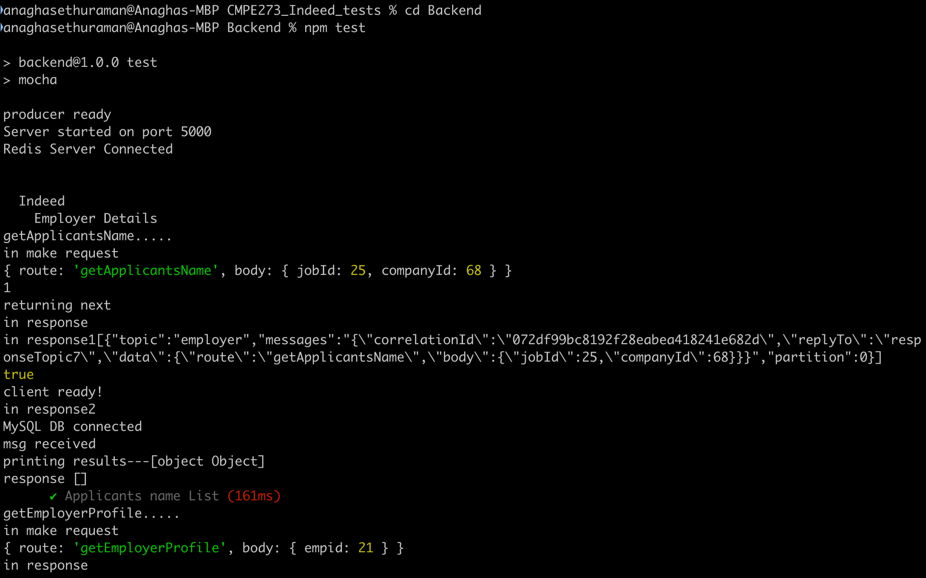

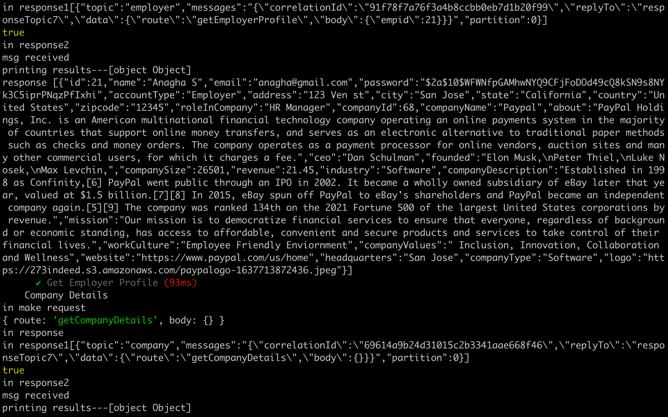

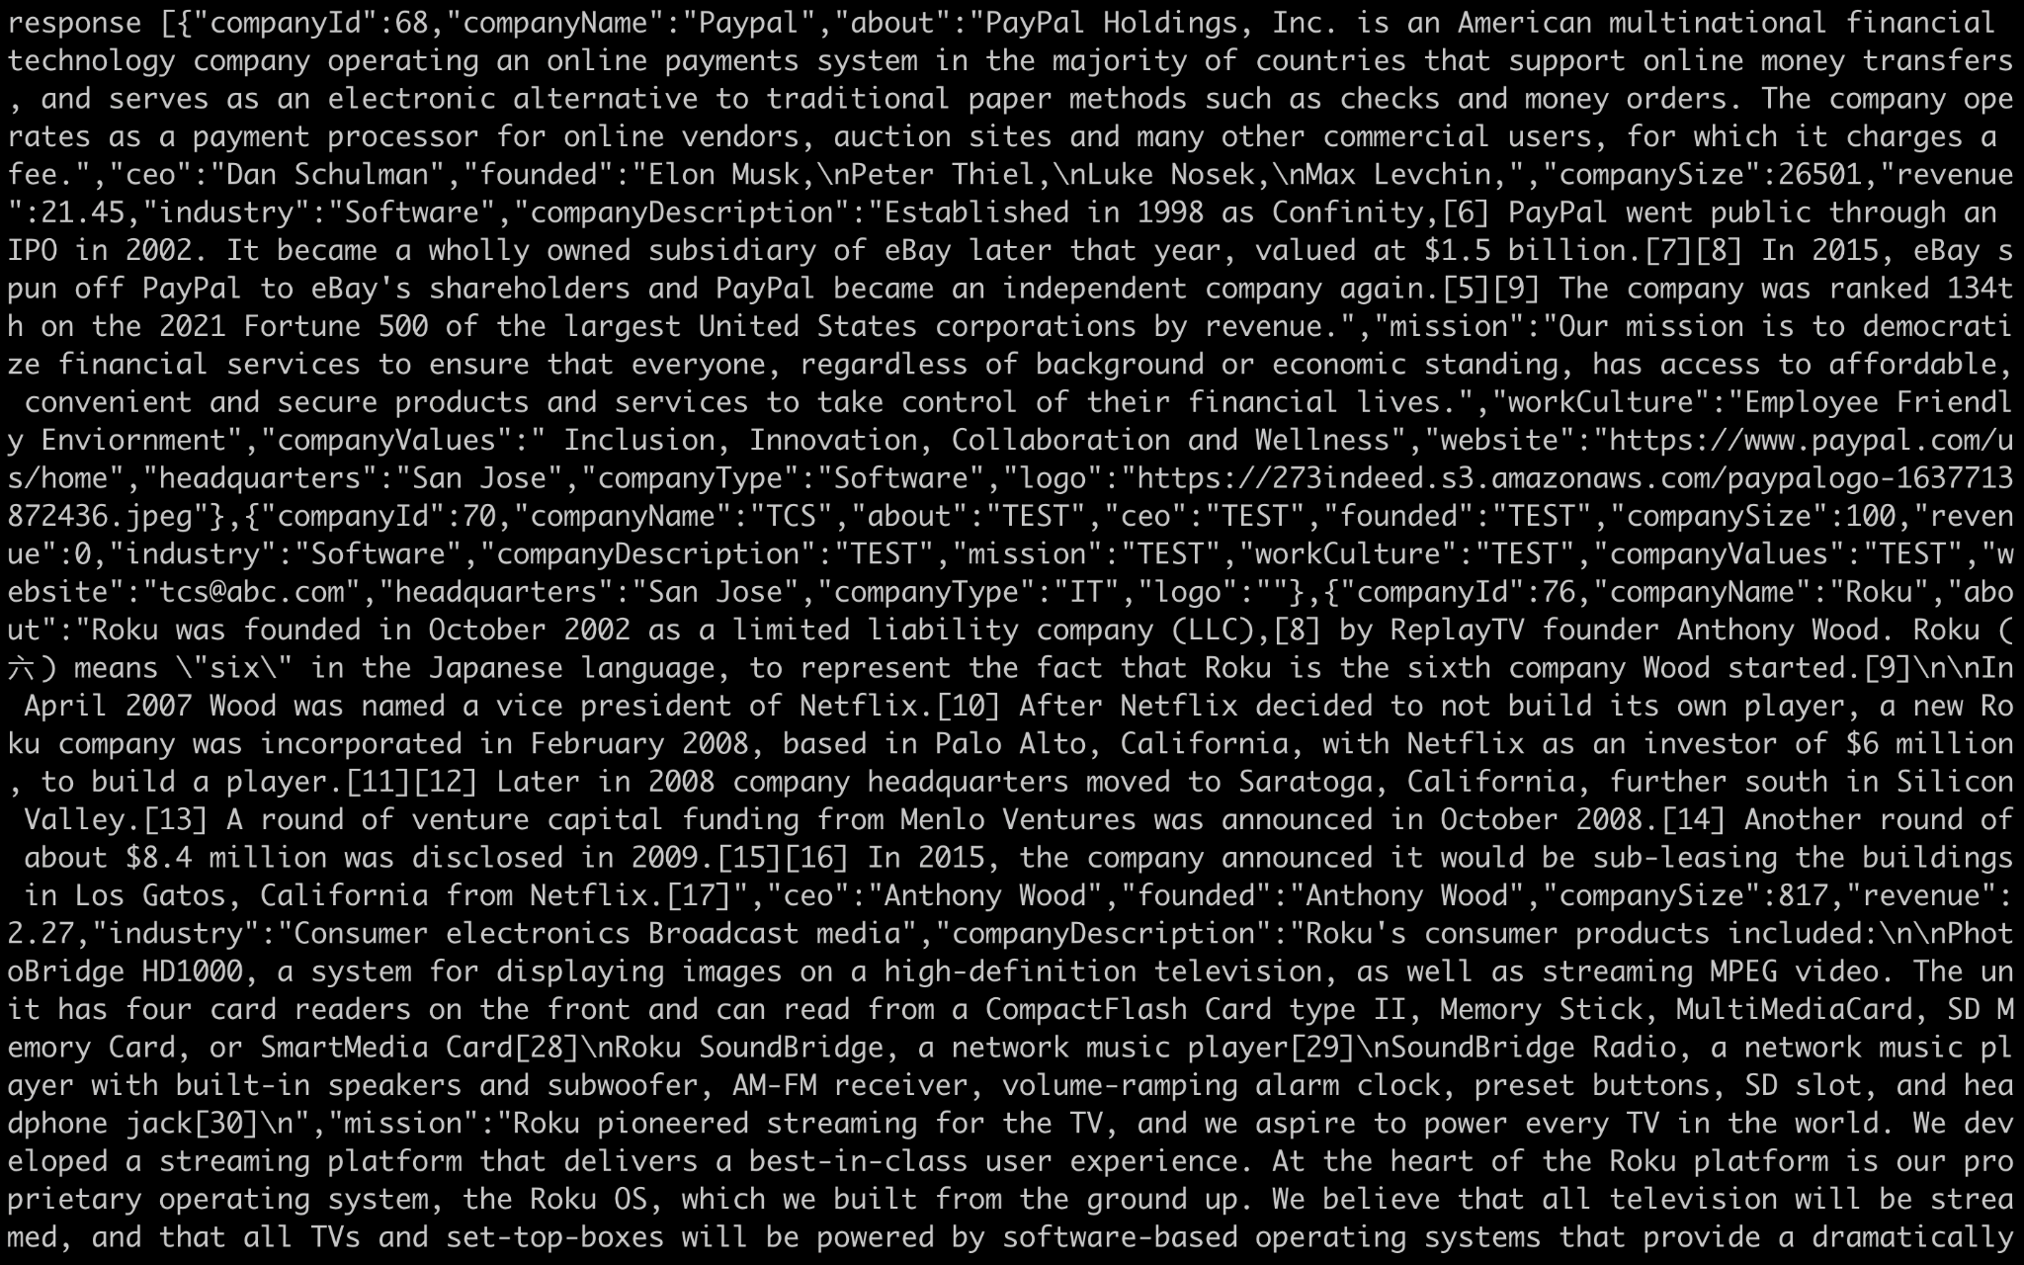

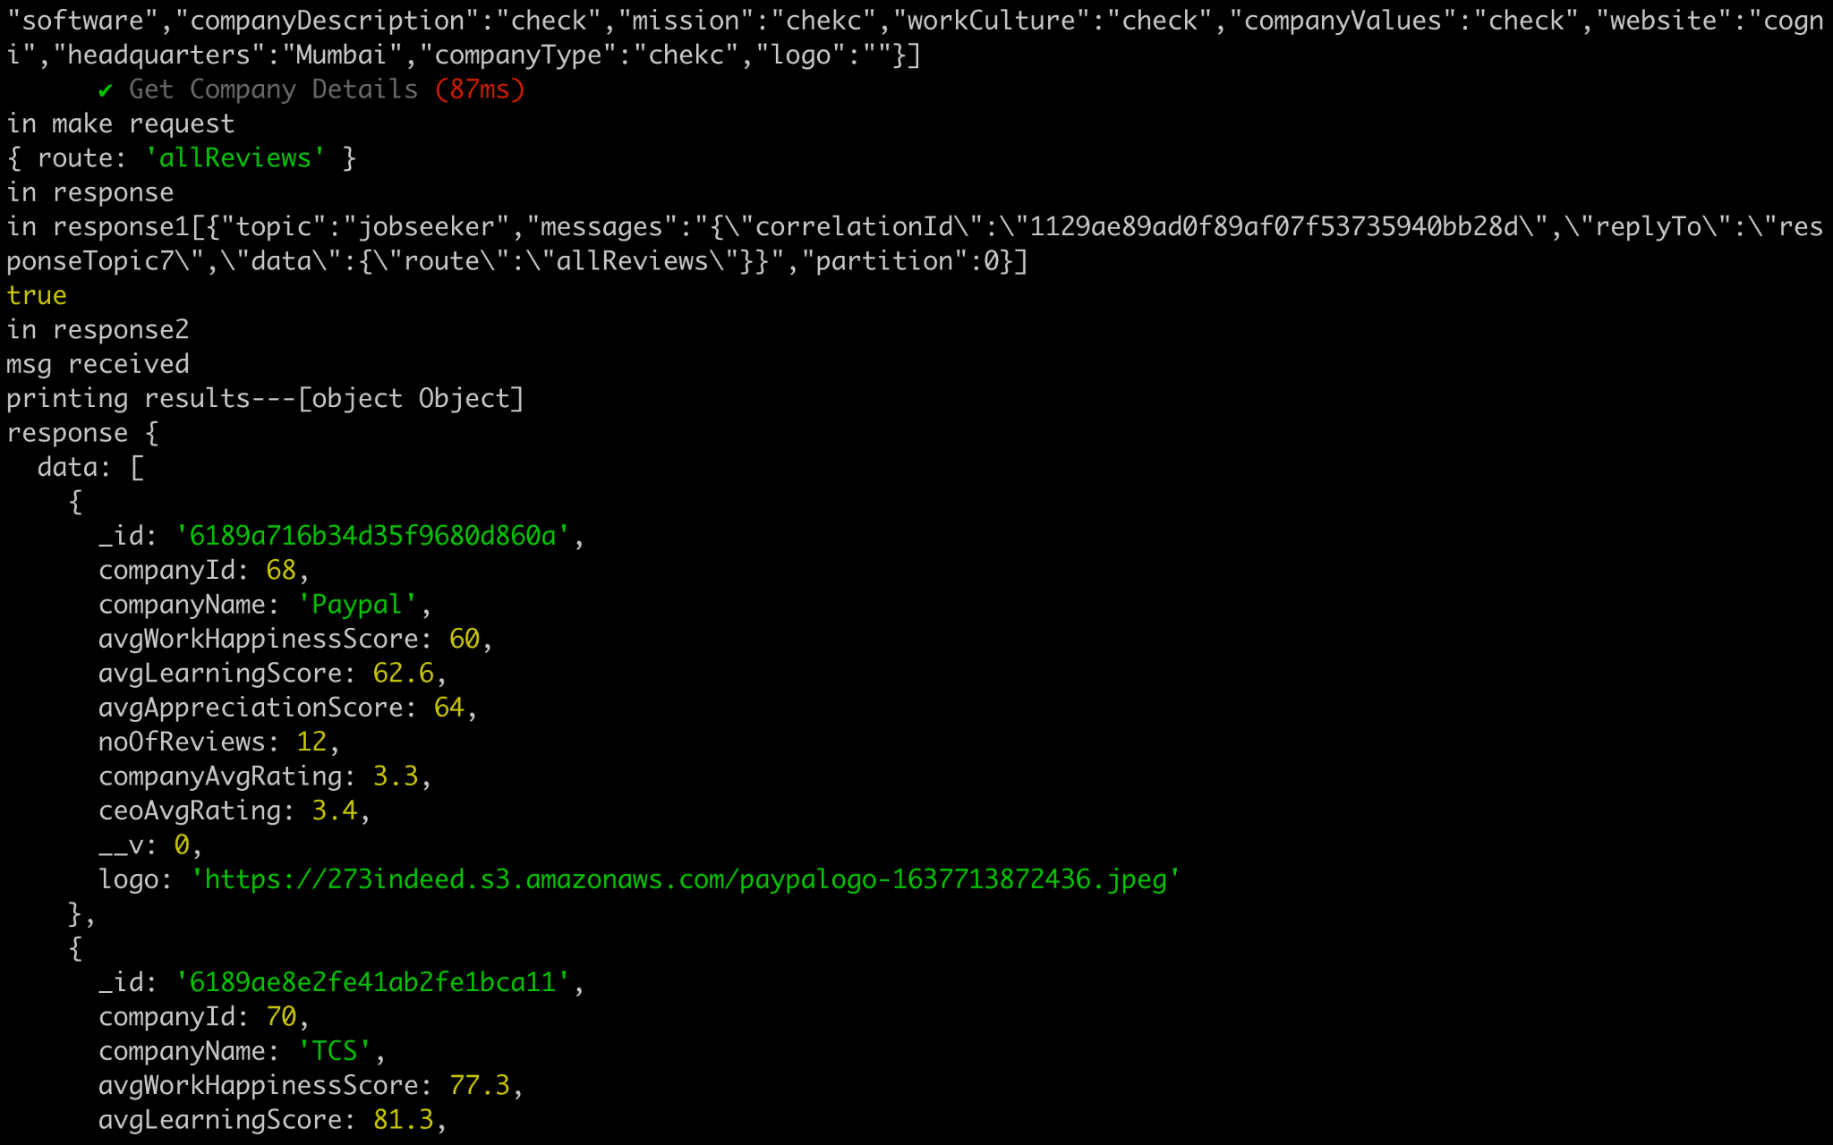

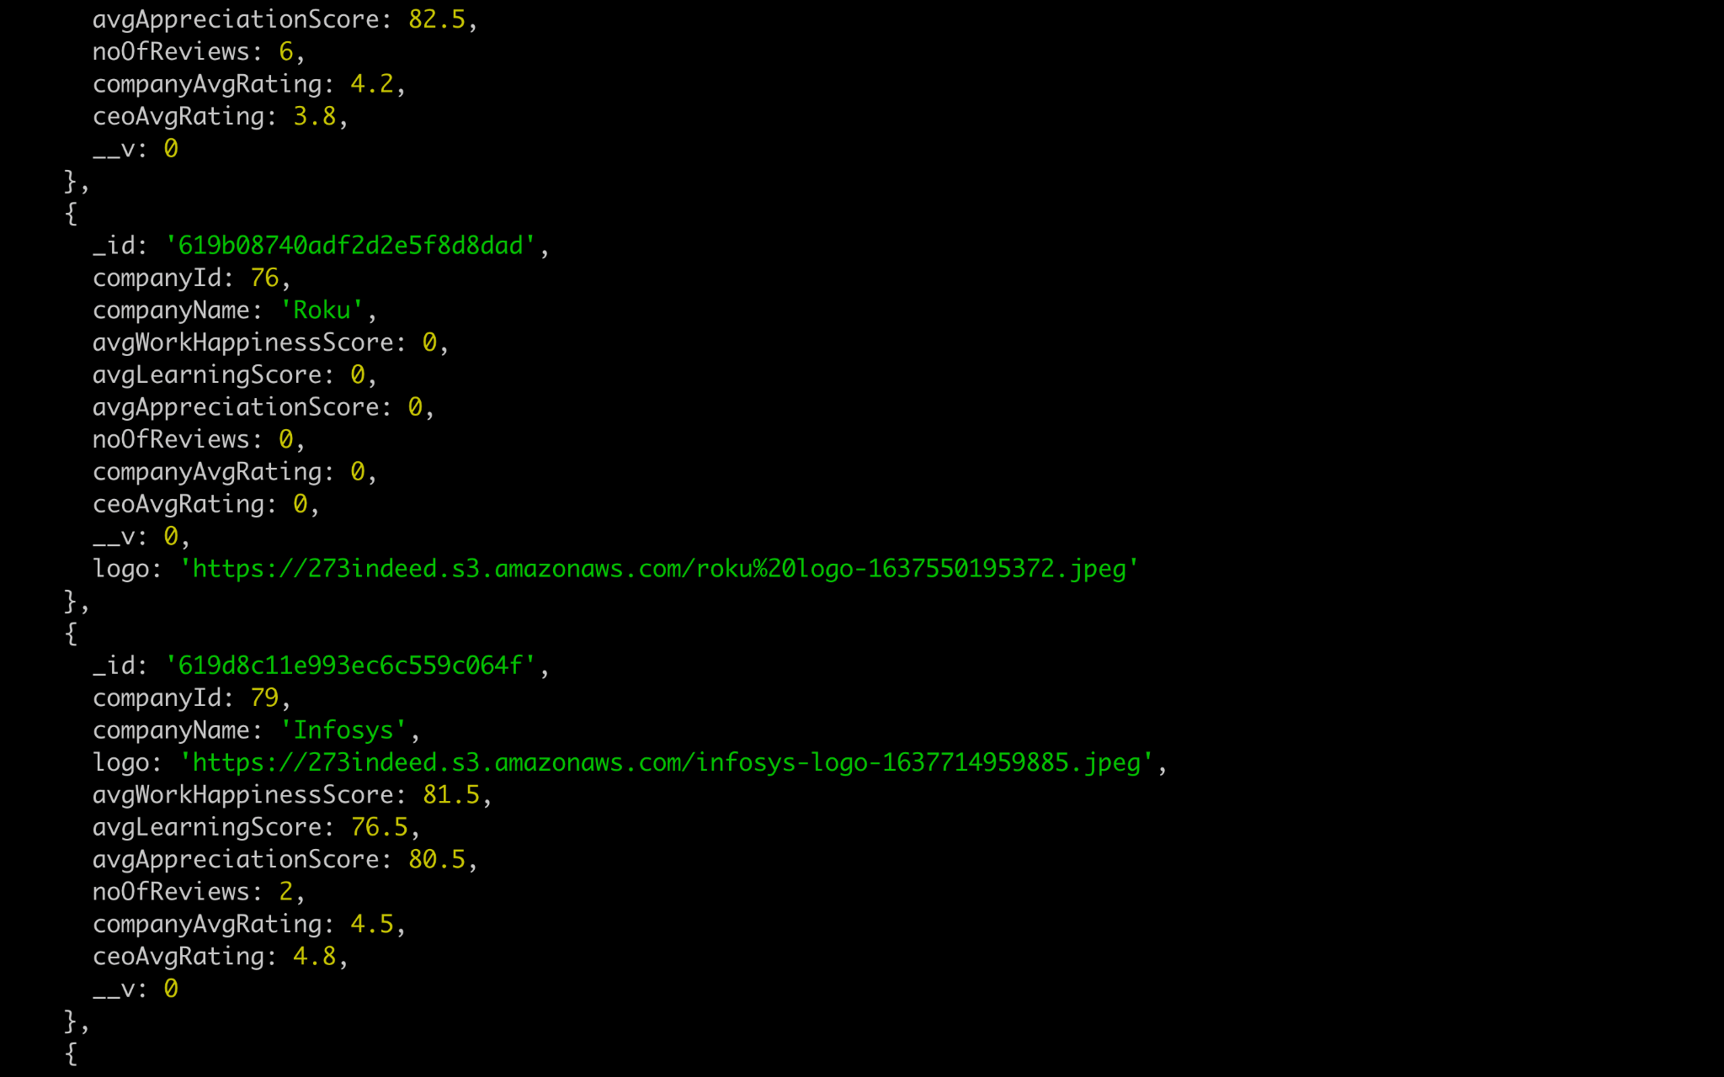



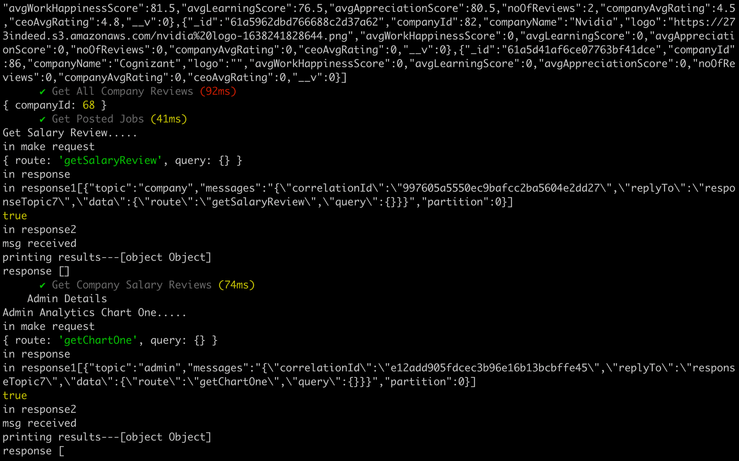

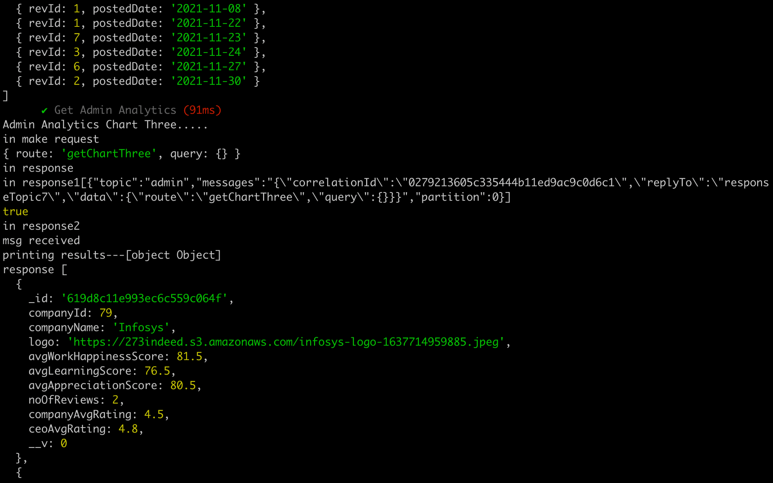



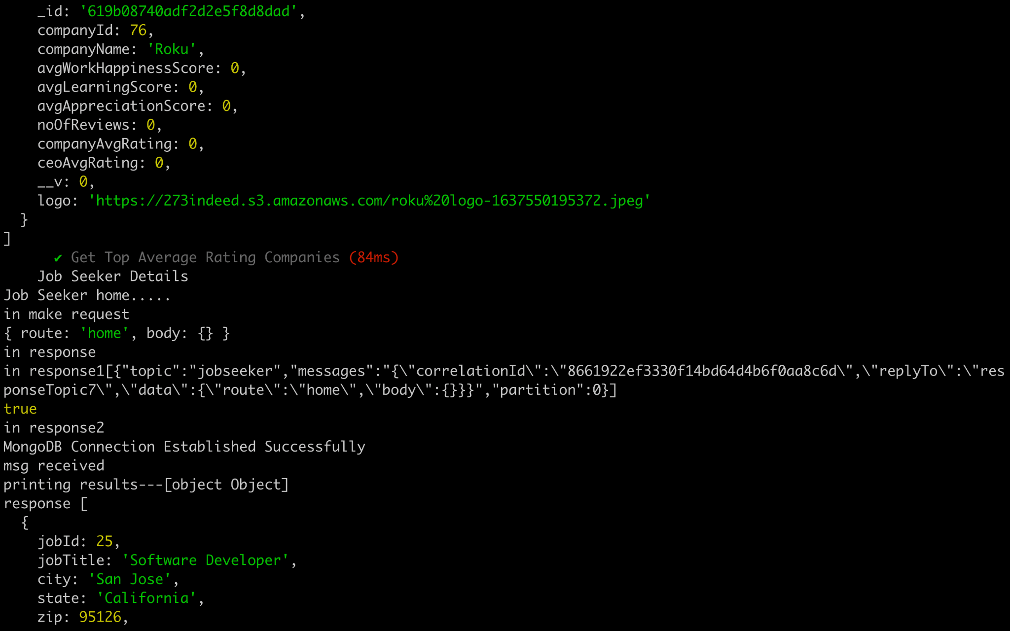

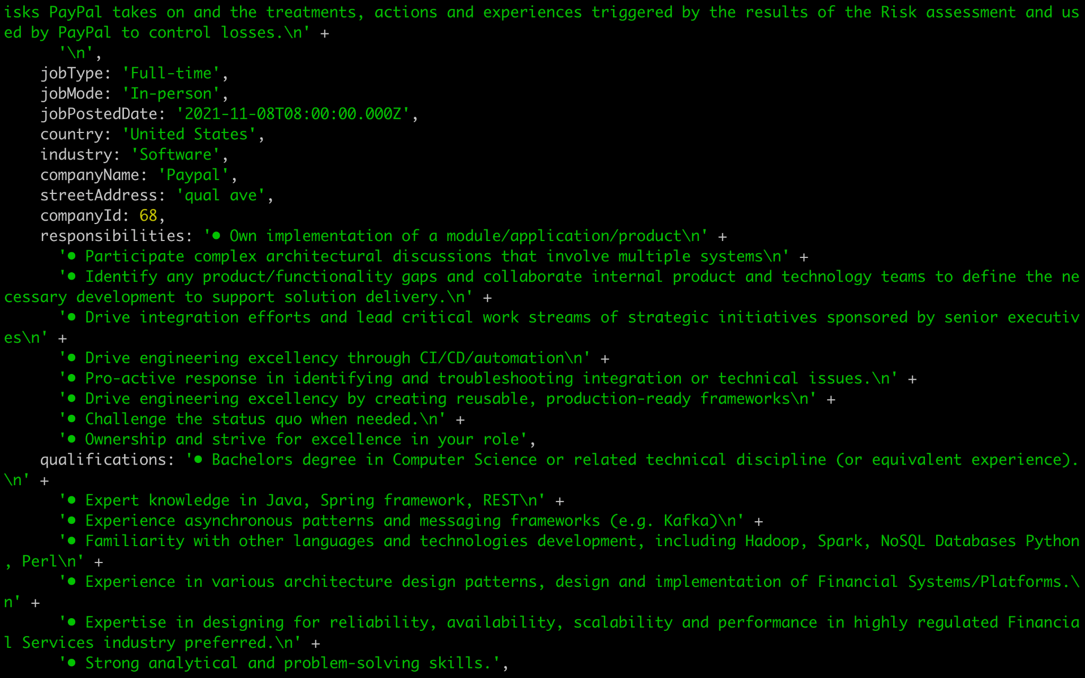

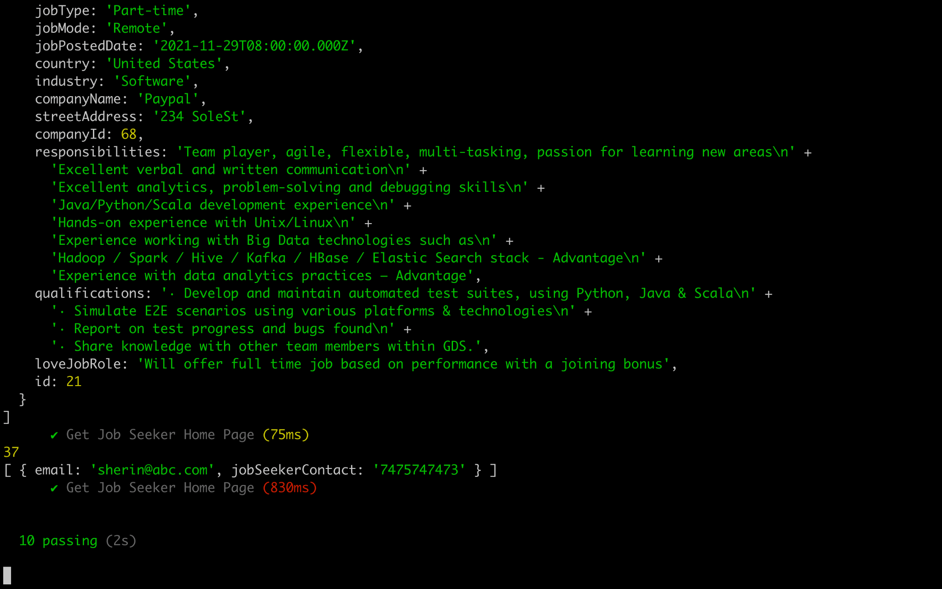

**Performance analysis and comparison**

* Performance of getAllUsrReviews API was tested with 10,000 reviews with and without distributed systems across various combinations.
* Performance improved by horizontally upscaling the number of servers in the load balancer configuration.
* Redis drastically increased performance due to caching.
* Kafka showed better performance as the request size increased.

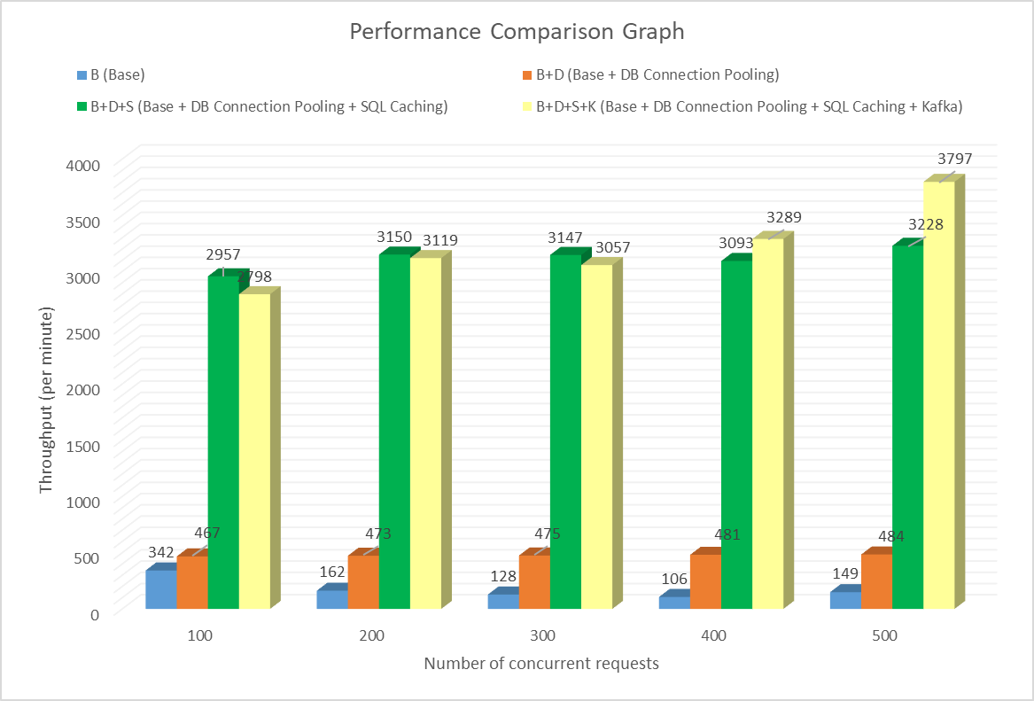

As we can see, with less number of users i.e. 100 and 200, base case performed the worst followed by pooling and kafka. Redis outperformed in this scenario, exceeding Kafka’s performance. This can be attributed to the fact that Kafka took more time delegating the requests for lesser users. However, when the total number of users increased(300,400,500) we can see that Kafka showed slight performance gain. The message handling mechanism paid off.

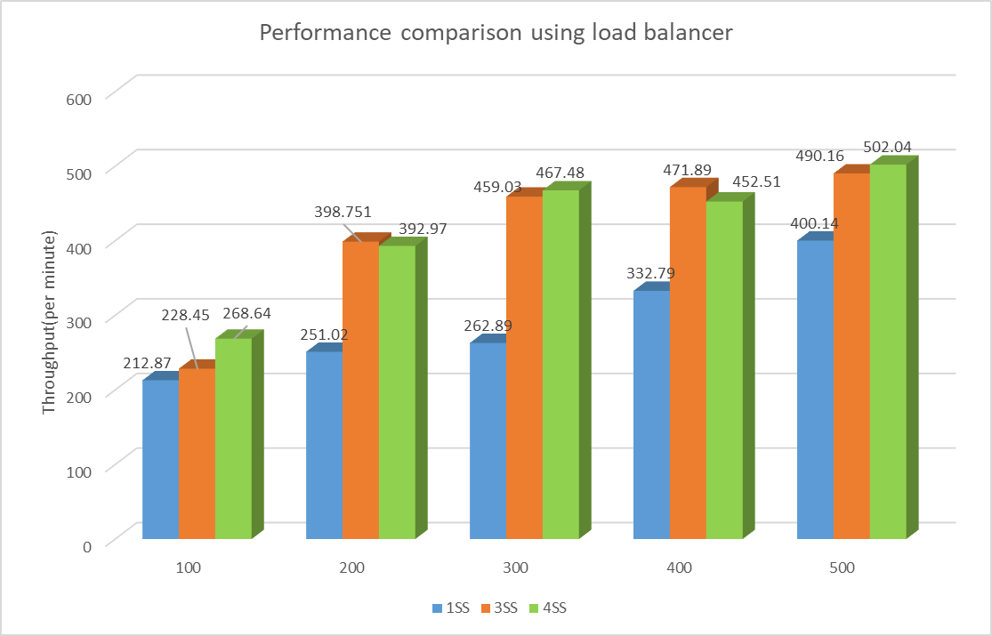

When we used multiple load balancers, we can see that with increase in the servers, the overall throughput also increased. This is because the request got distributed amongst multiple servers in round robin fashion, thereby providing a significant performance boost. For 200 and 400 users, we see that 3 servers very slightly outperform, but that result is skewed because of the network latency we were facing. The verdict we reached was that more servers performed better.

Code can be found at the below github repository link:

<https://github.com/ruchitadineshentoliya/CMPE273_Indeed.git>